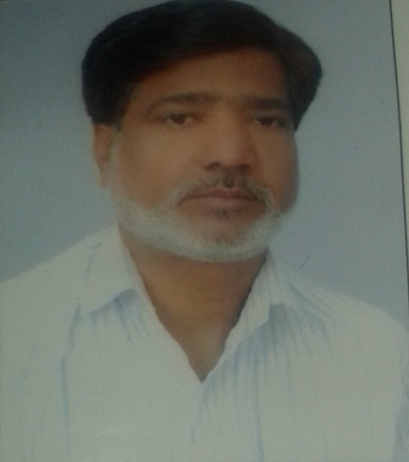

Mohd. Vasim
Bareilly, Utter pardesh, INDIA
vasimshaikh110786@gmail.com - 7387710932

For the Post : Admin/Back Office or PRO
Responsibilities :-
Basically I am responsible to promote our project according to need.
Dear Sir,
I am too much interested to do work with you but it should be in MUMBAI (MH) or UP. Just I am sending you all the details of my career. Please consider me positively. Thank you very much.
Objective:-

To achieve the excellence in an esteemed organization and up to greater through my hard work, accumulate the level and popularity of the organization.
Personal Profile:-
Mohd Vasim is cheerful, cultured ,laborious, energetic and down to earth people who believes in traditional value along with positive outlook towards life rationality, sincerity and honesty.
Criteria of Job Profile
H.R. (Back Office)/ Administrator
At present doing work as Regional Coordinator of URDU EDUCATION BOARD, DELHI

Academic Qualification

High School U.P.BOARD 1985 301/600 50.1% 2nd Hin,Eng,Math-2,Sci-2,Soci Sci & Bio
Intermediate U.P.BOARD 1987 232/500 46.4% 2nd Hindi,English,Math,Physics & Chemistry
B.A Agra Univ 2003 189/450 39.8% 3rd Found,Eng,Gen eng,Socio & Urdu

Other Qualification

Munshi Arbic board L 1998 326/700 46% 2nd Urdu Lit, Persian lit,Arabic & english

Kamil (B.A) J.U.A 1991 700/366 53% 2nd Hin,Eng,Arbi & Persian
Mo-Allim J.U. A 1998 800/364 48% 2nd Hindi,Urdu,Eng

Computer Skills
Adv. Dip in Comp Prog 1996 Excellent Com Centre A grade
Experience:
Excellent Comp Centre Comp Faculty 12 Apr 97 to 10 Apr 98 1 Yr Delhi
TFCSS Mkt Exe 2 Dec 98 to 15 Nov 99 1 Yr Noida
Wings Info Mkt Exe 10 Dec 99 to 10 Aug 2000 1 Yr Delhi
DataPro Mkt Mgr oct 2,2000- Oct 4,2004 2 Yr Delhi
National Education English Teacher Nov18, 2005 to oct8, 2008 3 Yrs Mumbai
Jamia Urdu Aligarh State Coordinator jan 1,2009 to dec 25, 2012 3 Yrs Mumbai
ZIIT English Teacher Nov25, 2008 to 14 6 Yrs Mumbai(part time classes)
Wings Infotech English Teacher Dec 15, 2014 to 17 3 Yrs Mumbai (part time classes)
Urdu Education Board National Coordinator 2013 to Current & currently doing work
Youtube channel I am also running youtube channel with name of “only for career” since last 10 months where I teach English to 9 to 12th of CBSE & UP BOARD.
BIG ADDA COACHING Since last 2 years I am teaching ENGLISH alongwith COMPETITIVE EXAM.

Personal Details
Name : Mohd. Vasim
Father’s Name : Late Mohd. Nasir
Date of Birth : 12/09/1970
Permanent Address : H.No-109, near 5 no road, partapur chaudhary,
Hari Kothi, 2nd Floor Izzatnagar, Bareilly, U.P
Correspondence Address : H.No-109, near 5 no road, partapur chaudhary,
Hari Kothi, 2nd Floor Izzatnagar, Bareilly, U.P

Email : vasimshaikh110786@gmail.com
Marital Status : Married and having three Kids.

Category : OBC

English Typing speed : 40+ words
Contact No : 7387710932/7895431757
Attitude : Positive & Hard working
Languages Known : Hindi, Urdu & English
Nationality : Indian
Hobby : To meet with unknown persons and gain more.
Declaration :- I hereby declare that all the information mentioned above is true and correct to best of my belief.
Date: 20 /03 /2021
Place: Bareilly (Utter Pardesh)
Yours

(Mohd. Vasim)
Note: I will be highly grateful to you if consider me positively.

