**Detailed Proposal**

**for**

**HealthcareMarketPlace**

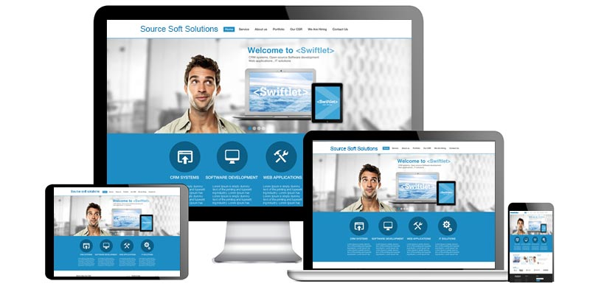

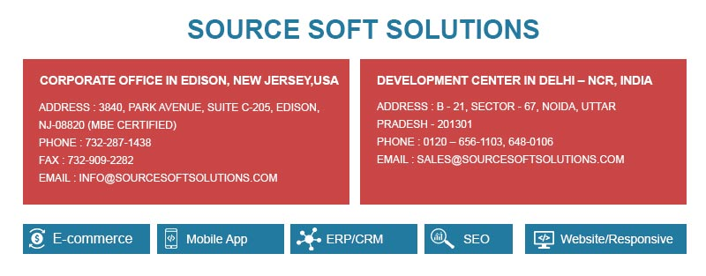

1. **Company Background**

Source Soft Solutions is an ISO 9001 certified company headquartered at USA with a team base of 80+ as leading providers in E-Commerce Portal, Custom Website Design and Development, Mobile app development and Innovative SEO services.

**Key Features**

1. Quick Response Time
2. Specialized team - Certified Professionals
3. Proven Track Record
4. Verifiable References
5. SLA Based Agreements
6. Specialized and Focused Service Area
7. Agile/Waterfall Methodology
8. World Class Infrastructure
9. ISO Based Processes
10. **Scope**

Design and Development of Website and APP for Fashion Brand Products

Development of Admin Panel

1. **Environment**
2. **Definitions, Acronyms and Abbreviations**

The following definitions, acronyms, and abbreviations shall apply throughout this SOW unless defined otherwise hereinafter:

|  |  |
| --- | --- |
| **Term** | **Definition** |
| CMS | [Content Management System](https://en.wikipedia.org/wiki/Content_management_system) |
| LAMP | [Platform consisting of Linux, Apache, My SQL and Perl/PHP/Python](https://en.wikipedia.org/wiki/LAMP_(software_bundle)) |
| MVC | [Model-view-controller](https://en.wikipedia.org/wiki/Model–view–controller) |
| RWD | [Responsive Web Design](https://en.wikipedia.org/wiki/Responsive_web_design) |
| SOW | [Statement of Work](https://en.wikipedia.org/wiki/Statement_of_work) |
| UI | [User Interface](https://en.wikipedia.org/wiki/User_interface) |
| UX | [User Experience](https://en.wikipedia.org/wiki/User_experience) |

1. **Web Scope**

**Function of User (customer):**

1. A site where anyone can come and post their Healthcare Products, specified Used or New or Business Entity.

  - Select specialty category of product to be posted

- Price independently by Seller - Upload options of pictures of product/s front, back, sides (1-12 pictures)

- Standard Name of products, nick names, popular names

- Number of items available for current posting. (May be edited, decreased or increased by seller).

-  Description of Product/s, condition of product, if used any maintenance history. Sell as it is notice.

  - Location of Product, any unique shipment needs  
    - Product shipment cost added, state and country tax if applicable to USA jurisdiction.

2. Sign up option for Buyers, user name and account. Guest only Account for posting use only or full account. (Sign in not necessary for one time Guest use only. This can be used again and again).

   - For Full sign in-  Buyers name, business name,  address, email, phone number, profession, current work, how many years in work or profession,

3. Sign up option for Sellers - Guest seller only one time user or permanent Account.  
     - For Full sign in - Sellers name, business name,  address, email, phone number, profession, current work, how many years in work or profession,   
     - Option to sign up (Business name as  primary Seller, name of company representative, position in business or company, proof person is authorized to act on behalf of company)

   - Set Commission rate for Healthcare800 Market Place by percentage of Sales Amount.

4. Healthcare800 Market Place - Product Verification process. Clients may post product, marked unverified. Once verified, check verified. Site Administrator may take down unverified or false claim products. -  Add disclaimer for false advertisers.

5. Display screen for website visitor to view products. (List all stages of sales from A- H on top of screen and show client as they move from A to B to C, - H) as they move from one stage to the other so they can understand where they are each step of the purchase process. With options to return back to previous or any stage at any time during the sales, until payment is made and accepted at final stage.

  a. Access by Location, Used, New, Bus. Entity and then Category of Specialty in health Care - (We Create these Specialty) Client will select one category - then proceed next to b.

   b. System will automatically select country location of client, but give option for client to manually chose a country they want to view posted product.

   c. Within the Country selected,   
      1. Option to divide country or provide a country map selection of city  
      2.  New Products.

      3.  Used Products and Business entity

      4.  View All products also by Specialty category. Specialty created and set in database. which can be edited, added, removed or modified by Website administrators.

  Client proceed to view all listed product in category selected.

   d. Select a products, by click product and buy now.   Create a client shopping Cart.  
   e. Add items to purchase in cart. List all items selected for clients  review once completed. Option to remove or add more items to cart. Proceed to next step.  
   f.  Select shipment option, international tariff notice if applies   
   g.  Product warnings, special handling items notice, and all necessary disclaimer option. Proceed to add more product/s to cart. Final to Payment platform.  
   h. Payment by credit card/Pay Pal, option to pay by Check within USA and delivery after check is cleared. Sellers responsibility to ship or money refunded to buyer in specified days.

**Administrative** **Panel**

The back end of the website will be power packed with an administrative panel to manage the updates of data. Following are the key functionalities:

**Assumptions:**

* + We assume that Webwill be in English

# Testing & QA Phase:

* **Unit testing:**

Unit testing is a software development process in which the smallest testable parts of an application, called units, are individually and independently scrutinized for proper operation.

* **Integration Testing:**

Testing the data flow between the modules

* **System/ Device Testing:**

It is performed to check whether all end to end business logic working or not

* **User Acceptance Testing:**

Testing is performed by the client

* **Alpha Testing:**

Alpha testing is a type of acceptance testing; performed to identify all possible issues/bugs before releasing the product to users

* **Beta Testing:**

Beta Testing of a product is performed by "real users" of the software application in a "real environment" and can be considered as a form of external user acceptance testing.

* **Client feedback / Reviews / Approvals/ Deployment**

1. **Project Estimation**

* **Total Cost: USD Only**
* **Total Timelines: Within Business Days**
  + Web Design = 12 Business Days
  + Admin and Backend Development: 25 Business Days
  + Website Development: 43 Business Days
  + QA: 10 Business Days

* The website & admin backend timeline are mentioned separately to show the required efforts for website and backend. However, our team will work on both in parallel, so the final timelines will be 28-30 Business Days as consolidated time.

** This quote is valid for 4 weeks from the proposal date.

1. **Time Lines for Project Execution**

|  |  |  |  |
| --- | --- | --- | --- |
|  | **Month 1** | **Month 2** | **Month 3** |
| **Web Design** | Business Days |  |  |
| **Admin and Backend Development** | Business Days |  |  |
| **Website Development** | Business Days |  |  |
| **Testing** |  | Business Days |  |

1. **Payment Schedule**

|  |  |  |  |
| --- | --- | --- | --- |
| **S. No.** | **Parameters** | **Rate** | **Amount** |
| **1** | Upfront Payment – Prior to kick off the Project |  | USD |
| **2** | UI Design Finalization |  | USD |
| **4** | On Final Delivery- Project Completion |  | USD |
| **5** | **Total Quote** |  | **USD Only** |
|  |  |  |  |

1. **Highlights**
2. The commercial cost to design and develop this project will be in USD only.
3. Logo will be provided by Source Soft Solutions as complimentary.
4. Project Start: Project would start within one week of awarding.
5. Staging server provided for interim and fast paced delivery
6. Source code protected under NDA & IPR and is owned by client
7. Project Collaboration and Management tools available for tracking
8. Any third party tool, module or component would be paid and owned by client.
9. **Requirements from Client**

1. Making choices where the choice impacts the timeline and cost towards an alternative which reduces timelines and costs, balance out on timeline and features.
2. Giving sign-off on designs shared. Ensuring feedback on UI and UX concepts within 2 business days. Any delay will increase the timeline by that many days.
3. Ensuring testing of the website development release testing by their users starting 15 working days before the website release date. Ensuring they have appropriate devices to test the website at least 7 days before the delivery date.
4. Feedback on website flow within 2 business days of receiving the website flow.
5. Buying servers and account details and providing Source Soft with the credential.
6. **Terms and Conditions**
7. Invoice shall be raised on each milestone, to be defined at the time of creation of Project Plan.
8. In case the need to make the resource(s) available onsite for study/delivery or any other purpose the cost shall be borne by the client (a separate scope of work is provided by Source Soft Solutions as the need arises).
9. Neither party can hire/contact/work with either of its employees/resources/former employees directly or indirectly during the term of this contract and till 5 years without the written permission from the directors of the company.
10. This proposal will be only valid once we receive a signed copy of the same from client’s end along.
11. Deliverables listed in the proposal above will be referred to during the development of the project. Any new features, additional modules, major changes in work flow or any other element which is out of scope as per the above will attract a fresh ETA and quote which will be submitted separately by Source Soft Solutions.
12. All content, images, texts, videos, Third party integration, services, API, Plug-in etc. information will be provided by the Client. If any of those attracts any cost to be acquired, same will be borne by the Client.
13. Source Soft Solutions is not liable to write or publish the content on the project.
14. Source Soft Solutions is not responsible for the delay of the project if the necessary information required by the Client like API’s information, third party plug-ins, Payment gateways and shipping gateways info etc. is not provided timely by the Client.
15. Source Soft Solutions will provide 3 design concepts for Design work and there will be 2-3 revisions can be done as per Client’s remarks if more revisions required then these will be billable.
16. Source Soft Solutions is not responsible for the delay caused by the malfunctioning of any third party software integrated with some other appreciated works:
17. General features not described in detail will carry out as per industry standards and will be supported by open source scripts when available. For example if a feature like forum is required we will use PHPBB.
18. Domain Registration & Hosting Server for the installation of final product will be bought by the Client and provided to Source Soft Solutions.
19. Client will ensure that the hosting server provided is compliant to the requirements for hosting server provided by Source Soft Solutions.
20. **Execution/Signature Block**

**IN WITNESS WHEREOF, both parties hereto have agreed the finalized scope for this project as of the date.**

**CLIENT: SERVICE PROVIDER:**

**Source Soft Solutions Pvt. Ltd.**

Title: ____________________ Title: _______________________

