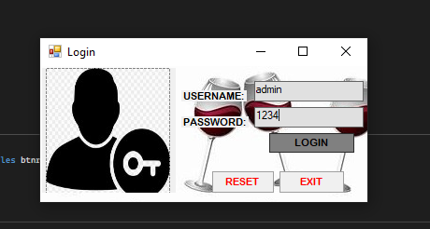

Imports System.Drawing.Imaging
Imports System.Net.Security
Imports System.Text
Imports Ingres.Client

Public Class Form1
Private Sub btnlogin_Click(sender As Object, e As EventArgs) Handles btnlogin.Click
If txtuname.Text = "admin" And txtpword.Text = "1234" Then
Me.Hide()

Form2.Show()

ElseIf txtuname.Text = "" And txtpword.Text = "" Then
MsgBox("Please Enter: UserID & Password")

Else
MsgBox("Wrong: 'Username & Password'")
End If
End Sub

Private Sub btnreset_Click(sender As Object, e As EventArgs) Handles btnreset.Click
txtuname.Text = ""
txtpword.Text = ""

Me.btnreset.Enabled = False
End Sub

Private Sub btnexit_Click(sender As Object, e As EventArgs) Handles btnexit.Click
Close()
End Sub
End Class

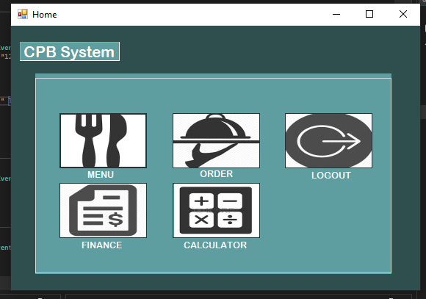
Public Class Form2
Private Sub btnmenu_Click(sender As Object, e As EventArgs) Handles btnmenu.Click
Form3.Show()
End Sub

Private Sub btnorder_Click(sender As Object, e As EventArgs) Handles btnorder.Click
Form4.Show()
End Sub

Private Sub btnfinance_Click(sender As Object, e As EventArgs) Handles btnfinance.Click
Form5.Show()
End Sub

Private Sub btnlogout_Click(sender As Object, e As EventArgs) Handles btnlogout.Click
Form1.Show()
Me.Close()
End Sub

Private Sub btncalculator_Click(sender As Object, e As EventArgs) Handles btncalculator.Click
Form6.Show()
End Sub

Private Sub RadMenuItem1_Click(sender As Object, e As EventArgs)

End Sub
End Class
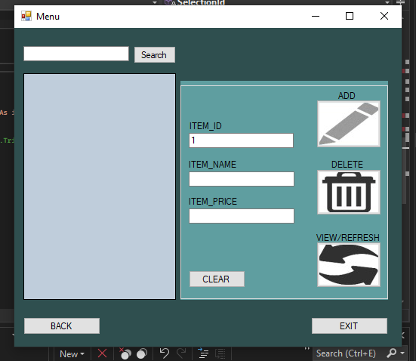

'imports library "add to reference"
Imports Ingres.Client

Public Class Form3

Dim i As Integer = 0

'Ingress connection
Public IngresConnect As New IngresConnection("host=172.17.243.202;database=ann_hotelreservation_db;user id=ingres;password=71xLR!m3&OPH;tz=philippines;")

'Form connection to DB
Private Sub Form3_Load(sender As Object, e As EventArgs) Handles MyBase.Load
IngConn1 = "host=172.17.243.202;database=ann_hotelreservation_db;user id=ingres;password=71xLR!m3&OPH;tz=philippines;"

Call SelectionId()

i = i + 1
txtitemid.Text = CStr(i)
End Sub

#Region "ADD button of menu"
Private Sub btnadd_Click(sender As Object, e As EventArgs) Handles btnadd.Click
Try
Dim Table As New DataTable
Dim dt As New DataTable
Dim Results As String = "False | Error on saving"

With Table
.Columns.Add("itemid").AutoIncrement = True
.Columns("itemid").AutoIncrementSeed = 1
.Columns.Add("itemname")
.Columns.Add("itemprice")
End With

Table.Rows.Clear()
Table.Rows.Add(txtitemid.Text.ToString.Trim,
txtitemname.Text.ToString.Trim,
txtitemprice.Text.ToString.Trim)
'dtpdob.Value,

Results = CStr(SavingRecords(Table))

Dim Output As Boolean = False
Dim ErrMessage As String = ""
Output = CBool(Split(Results, "|")(0).ToString())
ErrMessage = Split(Results, "|")(1).ToString()
MsgBox(ErrMessage)

Call SelectionId()

Catch ex As Exception

End Try
End Sub

#End Region

'For selection of row in the Datagridview
#Region "DataGridView"
Private Sub DataGridView1_CellContentClick(sender As Object, e As DataGridViewCellEventArgs) Handles DataGridView1.CellContentClick
Try
Dim table As New DataTable
Dim x As Integer = DataGridView1.CurrentCell.RowIndex

txtitemid.Text = DataGridView1.Rows(x).Cells(0).Value.ToString.Trim
txtitemname.Text = DataGridView1.Rows(x).Cells(1).Value.ToString.Trim
txtitemprice.Text = DataGridView1.Rows(x).Cells(2).Value.ToString.Trim
'dtpdob.Text = DataGridView1.Rows(x).Cells(4).Value
DataGridView1.DataSource = table

Catch ex As Exception
MsgBox(ex.Message)
End Try

End Sub
#End Region

Private Sub btnexit_Click(sender As Object, e As EventArgs) Handles btnexit.Click
Me.Close()
End Sub

Private Sub btnback_Click(sender As Object, e As EventArgs) Handles btnback.Click
Form2.Show()
End Sub

Private Sub btnclear_Click(sender As Object, e As EventArgs) Handles btnclear.Click
txtitemid.Clear()
txtitemname.Clear()
txtitemprice.Clear()
End Sub

'Create Private Sub to call function
'Declare 3 object Table, dta_record, query to call Db
#Region "MenuDisplay"
Private Sub MenuDisplay()

Try
Dim Table As New DataTable
Dim dta_record As New DataTable
Dim query As String = "SELECT MAX(itemid) + 1 as itemid FROM Menu"

'"SELECT MAX(itemid) + 1 as itemid FROM Menu"
If OpenFSConn() Then

Dim cmd As New IngresCommand
cmd.Connection = IngresConnect
cmd.CommandText = query
cmd.CommandType = CommandType.Text
cmd.Parameters.Clear()
Dim dta As New IngresDataAdapter(cmd)
dta.Fill(Table)
dta_record = Table

dta.Dispose()
CloseFSConn()

'txtitemid.Text = cmd.ExecuteScalar().ToString()
End If
DataGridView1.DataSource = Table
DataGridView1.Refresh()

Catch ex As Exception

End Try

End Sub
#End Region

#Region "OpenFSconn & CloseFSconn"
Public Function OpenFSConn() As Boolean
Dim Table As New DataTable

Dim IsOpen As Boolean = False

If IngresConnect.State = ConnectionState.Open Then Return True
Try
IngresConnect.Open()
Catch ex As Exception

End Try

If IngresConnect.State = ConnectionState.Open Then
Dim cm As New IngresCommand("set lockmode session where readlock=nolock", IngresConnect)
cm.ExecuteNonQuery()
IsOpen = True
End If
DataGridView1.DataSource = Table
DataGridView1.Refresh()

Return IsOpen
End Function

Public Sub CloseFSConn()
If IngresConnect.State = ConnectionState.Open Then IngresConnect.Close()
End Sub

#End Region

'Call Function of Menu Display
#Region "ViewDisplay"
Private Sub btnupdate_Click(sender As Object, e As EventArgs) Handles btnupdate.Click
'Dim table As DataTable
'Dim itemid As Integer = 0
'Dim newitemid As Integer = 0

'table = Selectinfo("sp_menu_sel", {})
'table.AcceptChanges()

Call SelectionId()

End Sub

#End Region

'For Delete Function
#Region "Delete"
Private Sub btndelete_Click(sender As Object, e As EventArgs) Handles btndelete.Click
Dim Table As DataTable

Try
Dim x As Integer = DataGridView1.CurrentCell.RowIndex

Dim itemid As String = DataGridView1.Rows(x).Cells(0).Value.ToString.Trim

Table = IngDataTablemenu("sp_menu_del",
{"int|" & itemid})

MsgBox("Successfully Deleted")

Catch ex As Exception
MsgBox(ex.Message)
End Try

End Sub

'For Search function the itemname see the query
#End Region

#Region "Search"
Private Sub btnsearch_Click(sender As Object, e As EventArgs) Handles btnsearch.Click

Try
Dim Table As New DataTable
Dim dta_record As New DataTable
Dim query As String = "Select * FROM Menu WHERE itemname Like '%" + txtsearch.Text + "%'"

If OpenFSConn() Then

Dim cmd As New IngresCommand
cmd.Connection = IngresConnect
cmd.CommandText = query
cmd.CommandType = CommandType.Text
cmd.Parameters.Clear()
Dim dta As New IngresDataAdapter(cmd)
dta.Fill(Table)
dta_record = Table

dta.Dispose()
CloseFSConn()

End If
DataGridView1.DataSource = Table
DataGridView1.Refresh()

Catch ex As Exception

End Try
End Sub
#End Region

#Region "Selection"
Private Sub SelectionId()

Try
Dim Table As New DataTable
Dim dta_record As New DataTable
Dim query As String = "Select MAX(itemid) + 1 As itemid FROM Menu"

'DataGridView1.Rows(i).Cells(0).Value.ToString.Trim = txtitemid.Text

If OpenFSConn() Then

Dim cmd As New IngresCommand
cmd.Connection = IngresConnect
cmd.CommandText = query
cmd.CommandType = CommandType.Text
cmd.Parameters.Clear()
Dim dta As New IngresDataAdapter(cmd)
dta.Fill(Table)
dta_record = Table

dta.Dispose()
CloseFSConn()

End If
DataGridView1.DataSource = Table
DataGridView1.Refresh()

Catch ex As Exception

End Try

End Sub
#End Region

End Class
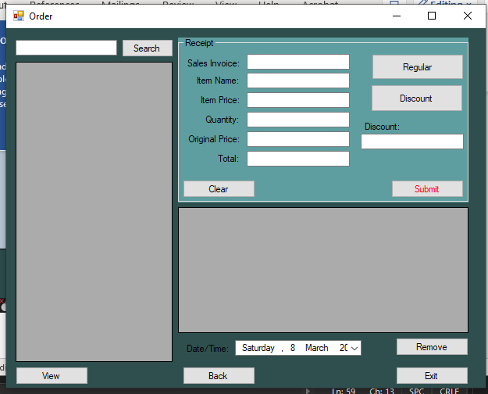
Imports System.Net.Mime.MediaTypeNames
Imports System.Windows.Forms.VisualStyles.VisualStyleElement

Imports Ingres.Client

Public Class Form4

Public IngresConnect As New IngresConnection("host=172.17.243.202;database=ann_hotelreservation_db;user id=ingres;password=71xLR!m3&OPH;tz=philippines;")

Private Sub Form4_Load(sender As Object, e As EventArgs) Handles MyBase.Load
IngConn1 = "host=172.17.243.202;database=ann_hotelreservation_db;user id=ingres;password=71xLR!m3&OPH;tz=philippines;"

Call orderview()
End Sub

'creation of function to call the menu records in Datagridview1
#Region "orderview"
Private Sub orderview()
Try
Dim Table As New DataTable
Dim dta_record As New DataTable
Dim query As String = "SELECT * FROM Menu"

If OpenFSConn() Then

Dim cmd As New IngresCommand
cmd.Connection = IngresConnect
cmd.CommandText = query
cmd.CommandType = CommandType.Text
cmd.Parameters.Clear()
Dim dta As New IngresDataAdapter(cmd)
dta.Fill(Table)
dta_record = Table

dta.Dispose()
CloseFSConn()

End If
DataGridView1.DataSource = Table
DataGridView1.Refresh()

Catch ex As Exception
MsgBox(ex.Message)
End Try

End Sub

#End Region

#Region "Open & Close FSConn"
Public Function OpenFSConn() As Boolean
Dim Table As New DataTable

Dim IsOpen As Boolean = False

If IngresConnect.State = ConnectionState.Open Then Return True
Try
IngresConnect.Open()
Catch ex As Exception

End Try

If IngresConnect.State = ConnectionState.Open Then
Dim cm As New IngresCommand("set lockmode session where readlock=nolock", IngresConnect)
cm.ExecuteNonQuery()
IsOpen = True
End If
DataGridView1.DataSource = Table
DataGridView1.Refresh()

Return IsOpen
End Function

Public Sub CloseFSConn()
If IngresConnect.State = ConnectionState.Open Then IngresConnect.Close()
End Sub

#End Region

#Region "Back & Exit"
Private Sub btnback_Click(sender As Object, e As EventArgs) Handles btnback.Click
Form2.Show()
Me.Close()
End Sub

Private Sub btnexit_Click(sender As Object, e As EventArgs) Handles btnexit.Click
Me.Close()
End Sub

#End Region

'computation of quantity
#Region "Quantity compute"
Private Sub txtquantity_TextChanged(sender As Object, e As EventArgs) Handles txtquantity.TextChanged

If Not IsNumeric(txtquantity.Text) Then
txtquantity.Clear()
End If

txttotal.Text = Val(txtitemprice.Text) * Val(txtquantity.Text)
txtoriginalprice.Text = Val(txtitemprice.Text) * Val(txtquantity.Text)
End Sub
#End Region

#Region "Search"
Private Sub btnsearch2_Click(sender As Object, e As EventArgs) Handles btnsearch2.Click
Try
Dim Table As New DataTable
Dim dta_record As New DataTable
Dim query As String = "Select * FROM Menu WHERE itemname Like '%" + txtsearch2.Text + "%'"

If OpenFSConn() Then

Dim cmd As New IngresCommand
cmd.Connection = IngresConnect
cmd.CommandText = query
cmd.CommandType = CommandType.Text
cmd.Parameters.Clear()
Dim dta As New IngresDataAdapter(cmd)
dta.Fill(Table)
dta_record = Table

dta.Dispose()
CloseFSConn()

End If
DataGridView1.DataSource = Table
DataGridView1.Refresh()

Catch ex As Exception

End Try
End Sub

#End Region

Private Sub btnremove_Click(sender As Object, e As EventArgs) Handles btnremove.Click

Dim Table As DataTable

Try
Dim x As Integer = DataGridView2.CurrentCell.RowIndex
Dim salesinvoice As String = DataGridView2.Rows(x).Cells(0).Value.ToString.Trim

Table = IngDataTableorderdel("sp_order_del",
{"int|" & salesinvoice})

MsgBox("Successfully Deleted")

Catch ex As Exception
MsgBox(ex.Message)
End Try
End Sub

Private Sub DataGridView1_CellContentClick_1(sender As Object, e As DataGridViewCellEventArgs) Handles DataGridView1.CellContentClick
Try
Dim table As New DataTable
Dim x As Integer = DataGridView1.CurrentCell.RowIndex

txtSINo.Text = DataGridView1.Rows(x).Cells(0).Value.ToString.Trim
txtitemname.Text = DataGridView1.Rows(x).Cells(1).Value.ToString.Trim
txtitemprice.Text = DataGridView1.Rows(x).Cells(2).Value.ToString.Trim
DataGridView1.DataSource = table

Catch ex As Exception
MsgBox(ex.Message)
End Try
End Sub

Private Sub btndatabase_Click(sender As Object, e As EventArgs) Handles btnSubmit.Click
Try
Dim Table As New DataTable
Dim Results As String = "False | Error on saving"

With Table
.Columns.Add("salesinvoice")
.Columns.Add("itemname")
.Columns.Add("itemprice")
.Columns.Add("quantity")
.Columns.Add("originalprice")
.Columns.Add("discounted")
.Columns.Add("total")
.Columns.Add("datetime")
End With

Table.Rows.Clear()
Table.Rows.Add(txtSINo.Text.ToString.Trim,
txtitemname.Text.ToString.Trim,
txtitemprice.Text.ToString.Trim,
txtquantity.Text.ToString.Trim,
txtoriginalprice.Text.ToString.Trim,
txtdiscounted.Text.ToString.Trim,
txttotal.Text.ToString.Trim,
dtpdatetime.Value)

Results = CStr(SavingRecords2(Table))

Dim Output As Boolean = False
Dim ErrMessage As String = ""
Output = CBool(Split(Results, "|")(0).ToString())
ErrMessage = Split(Results, "|")(1).ToString()
MsgBox(ErrMessage)

Call order()

Catch ex As Exception

End Try
End Sub

Private Sub order()
Try
Dim Table As New DataTable
Dim dta_record As New DataTable
Dim query As String = "SELECT * FROM order"

If OpenFSConn() Then

Dim cmd As New IngresCommand
cmd.Connection = IngresConnect
cmd.CommandText = query
cmd.CommandType = CommandType.Text
cmd.Parameters.Clear()
Dim dta As New IngresDataAdapter(cmd)
dta.Fill(Table)
dta_record = Table

dta.Dispose()
CloseFSConn()

End If
DataGridView2.DataSource = Table
DataGridView2.Refresh()

Catch ex As Exception

End Try
End Sub

Private Sub btnview_Click(sender As Object, e As EventArgs) Handles btnview.Click
Call orderview()

End Sub

Private Sub btnclear_Click(sender As Object, e As EventArgs) Handles btnclear.Click
txtSINo.Clear()
txtitemname.Clear()
txtitemprice.Clear()
txtquantity.Clear()
txtoriginalprice.Clear()
txtdiscounted.Clear()
txttotal.Clear()

End Sub

Private Sub btnregular_Click(sender As Object, e As EventArgs) Handles btnregular.Click
txttotal.Text = (Val(txtitemprice.Text) * Val(txtquantity.Text)) * (1 - 0.2)
txtdiscounted.Text = (Val(txtitemprice.Text) * Val(txtquantity.Text)) * (0.2)
End Sub

Private Sub btnsenior_Click(sender As Object, e As EventArgs) Handles btnsenior.Click
txttotal.Text = (Val(txtitemprice.Text) * Val(txtquantity.Text)) * (1 - 0.15)
txtdiscounted.Text = (Val(txtitemprice.Text) * Val(txtquantity.Text)) * (0.15)
End Sub

'Private Sub btnemployee_Click(sender As Object, e As EventArgs)
' txttotal.Text = (Val(txtitemprice.Text) * Val(txtquantity.Text))
' txtdiscounted.Text = 0
'End Sub

Private Sub DataGridView2_CellContentClick(sender As Object, e As DataGridViewCellEventArgs) Handles DataGridView2.CellContentClick
Try
Dim x As Integer = DataGridView2.CurrentCell.RowIndex
txtSINo.Text = DataGridView2.Rows(x).Cells(0).Value.ToString().Trim
txtitemname.Text = DataGridView2.Rows(x).Cells(1).Value.ToString().Trim
txtitemprice.Text = DataGridView2.Rows(x).Cells(2).Value.ToString().Trim
txtquantity.Text = DataGridView2.Rows(x).Cells(4).Value.ToString().Trim
txtoriginalprice.Text = DataGridView2.Rows(x).Cells(5).Value.ToString().Trim
txtdiscounted.Text = DataGridView2.Rows(x).Cells(6).Value.ToString().Trim
txttotal.Text = DataGridView2.Rows(x).Cells(7).Value.ToString().Trim
dtpdatetime.Text = DataGridView2.Rows(x).Cells(8).Value

Catch ex As Exception

End Try

End Sub

Private Sub Label1_Click(sender As Object, e As EventArgs) Handles Label1.Click

End Sub

Private Sub txtoriginalprice_TextChanged(sender As Object, e As EventArgs) Handles txtoriginalprice.TextChanged

End Sub
End Class

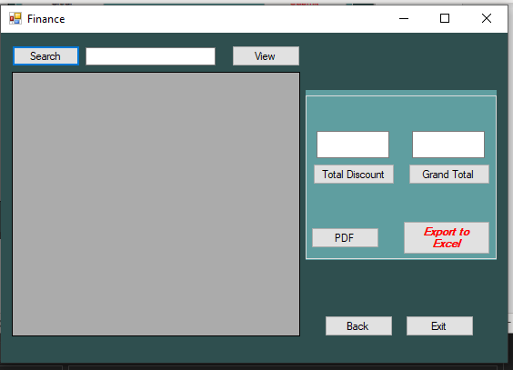
Imports Ingres.Client
Imports System.Data
Imports System.Data.SqlClient
Imports System.IO
Imports System.Net.Security
Imports System.Timers
Imports System.Windows.Forms.VisualStyles
Imports NPOI.XSSF.UserModel
Imports Christian_Auditing_System.Form5
Imports System.ComponentModel
Imports NPOI.SS.Formula.Functions
Imports Telerik.WinControls.Export
Imports System.Reflection
Imports iTextSharp.text
Imports iTextSharp.text.pdf

Public Class Form5

Public IngresConnect As New IngresConnection("host=172.17.243.202;database=ann_hotelreservation_db;user id=ingres;password=71xLR!m3&OPH;tz=philippines;")

Private Sub Form4_Load(sender As Object, e As EventArgs) Handles MyBase.Load

IngConn1 = "host=172.17.243.202;database=ann_hotelreservation_db;user id=ingres;password=71xLR!m3&OPH;tz=philippines;"

Call Financeorder()

End Sub

Public Sub New()
InitializeComponent()
Me.BindDataGridView()
End Sub

Private Sub BindDataGridView()
Dim dt As New DataTable()
dt.Columns.AddRange(New DataColumn() {New DataColumn("salesinvoice", GetType(Integer)),
New DataColumn("itemname", GetType(String)),
New DataColumn("itemprice", GetType(String)),
New DataColumn("quantity", GetType(String)),
New DataColumn("originalprice", GetType(String)),
New DataColumn("discounted", GetType(String)),
New DataColumn("total", GetType(String))})
Me.DataGridView1.DataSource = dt
End Sub

Private Sub Button1_Click(sender As Object, e As EventArgs) Handles btnsearch.Click
Try
Dim Table As New DataTable
Dim dta_record As New DataTable
Dim query As String = "Select * FROM order WHERE itemname Like '%" + txtsearch.Text + "%'"

If OpenFSConn() Then

Dim cmd As New IngresCommand
cmd.Connection = IngresConnect
cmd.CommandText = query
cmd.CommandType = CommandType.Text
cmd.Parameters.Clear()
Dim dta As New IngresDataAdapter(cmd)
dta.Fill(Table)
dta_record = Table

dta.Dispose()
CloseFSConn()

End If
DataGridView1.DataSource = Table
DataGridView1.Refresh()

Catch ex As Exception

End Try
End Sub

Private Sub Financeorder()
Try
Dim Table As New DataTable
Dim dta_record As New DataTable
Dim query As String = "SELECT * FROM Order"

If OpenFSConn() Then

Dim cmd As New IngresCommand
cmd.Connection = IngresConnect
cmd.CommandText = query
cmd.CommandType = CommandType.Text
cmd.Parameters.Clear()
Dim dta As New IngresDataAdapter(cmd)
dta.Fill(Table)
dta_record = Table

dta.Dispose()
CloseFSConn()

End If
DataGridView1.DataSource = Table
DataGridView1.Refresh()

Catch ex As Exception
MsgBox(ex.Message)
End Try
''configuration for save file dialog
'SaveFileDialog1.FileName = ""
'SaveFileDialog1.Filter = "PDF (*.pdf)|*.pdf"

End Sub

#Region "Open & CLose FSConn"
Public Function OpenFSConn() As Boolean
Dim Table As New DataTable

Dim IsOpen As Boolean = False

If IngresConnect.State = ConnectionState.Open Then Return True
Try
IngresConnect.Open()
Catch ex As Exception

End Try

If IngresConnect.State = ConnectionState.Open Then
Dim cm As New IngresCommand("set lockmode session where readlock=nolock", IngresConnect)
cm.ExecuteNonQuery()
IsOpen = True
End If
DataGridView1.DataSource = Table
DataGridView1.Refresh()

Return IsOpen
End Function

Public Sub CloseFSConn()
If IngresConnect.State = ConnectionState.Open Then IngresConnect.Close()
End Sub

#End Region
Private Sub Button4_Click(sender As Object, e As EventArgs) Handles btnexport.Click
Try
Dim worker As New System.ComponentModel.BackgroundWorker
AddHandler worker.DoWork, AddressOf ExportLoad
AddHandler worker.RunWorkerCompleted, AddressOf ExportCompleted
worker.RunWorkerAsync()
Catch ex As Exception
MsgBox(ex.Message)
End Try
End Sub

Public Structure ResultExporXYZ
Dim isSuccess As Boolean
Dim hssfwb As XSSFWorkbook
End Structure

Private Sub ExportLoad(ByVal sender As System.Object, ByVal e As System.ComponentModel.DoWorkEventArgs)
Dim Result As New ResultExporXYZ

Result.isSuccess = False

Try
Dim hssfwb = New XSSFWorkbook(NPOI.OpenXml4Net.OPC.OPCPackage.Open(New MemoryStream(My.Resources.template)))

Dim formatSheet As XSSFSheet = hssfwb.GetSheet("Sheet1")
Dim copyrow As XSSFRow = formatSheet.GetRow(0)
Dim begincounter As Integer = 1

For X As Integer = 0 To DataGridView1.Rows.Count - 1
copyrow.CopyRowTo(begincounter)
Dim cellrow As XSSFRow = formatSheet.GetRow(begincounter)
cellrow.GetCell(0).SetCellValue(DataGridView1.Rows(X).Cells(0).Value.ToString)
cellrow.GetCell(1).SetCellValue(DataGridView1.Rows(X).Cells(1).Value.ToString)
cellrow.GetCell(2).SetCellValue(DataGridView1.Rows(X).Cells(2).Value.ToString)
cellrow.GetCell(3).SetCellValue(DataGridView1.Rows(X).Cells(3).Value.ToString)
cellrow.GetCell(4).SetCellValue(DataGridView1.Rows(X).Cells(4).Value.ToString)
cellrow.GetCell(5).SetCellValue(DataGridView1.Rows(X).Cells(5).Value.ToString)
cellrow.GetCell(6).SetCellValue(DataGridView1.Rows(X).Cells(6).Value.ToString)
cellrow.GetCell(7).SetCellValue(DataGridView1.Rows(X).Cells(7).Value.ToString)

begincounter += 1
Next

Result.hssfwb = hssfwb
Result.isSuccess = True
Catch ex As Exception
MsgBox(ex.Message)
End Try
e.Result = Result
End Sub

Private Sub ExportCompleted(ByVal sender As System.Object, ByVal e As System.ComponentModel.RunWorkerCompletedEventArgs)
Dim Result As ResultExporXYZ = e.Result

If Result.isSuccess = True Then
Dim SaveDialog As New SaveFileDialog
SaveDialog.Title = "Save Report"

SaveDialog.Filter = "Excel Files|*.xlsx"
SaveDialog.FilterIndex = 1
If SaveDialog.ShowDialog = DialogResult.OK Then
Try
Dim xlFileName As String = SaveDialog.FileName

Dim xfile As New FileStream(SaveDialog.FileName, FileMode.Create, System.IO.FileAccess.Write)
Result.hssfwb.Write(xfile)
xfile.Close()
Process.Start(SaveDialog.FileName)
Catch ex As Exception
MsgBox(ex.Message)
End Try
End If
End If
End Sub

Private Sub Button1_Click_1(sender As Object, e As EventArgs) Handles btnview.Click
Call Financeorder()
End Sub

Private Sub Button8_Click(sender As Object, e As EventArgs) Handles btnback.Click
Form2.Show()
End Sub

Private Sub btnclose_Click(sender As Object, e As EventArgs) Handles btnclose.Click
Me.Close()
End Sub

Private Sub Button5_Click(sender As Object, e As EventArgs) Handles btntotaldiscount.Click
Dim SUM As Integer

For i As Integer = 0 To DataGridView1.RowCount - 1

SUM += DataGridView1.Rows(i).Cells(5).Value
Next
txttotaldiscount.Text = SUM.ToString

End Sub
Private Sub Button6_Click(sender As Object, e As EventArgs) Handles btngrandtotal.Click

Dim gtot As Integer

For i As Integer = 0 To DataGridView1.RowCount - 1

gtot += DataGridView1.Rows(i).Cells(6).Value
Next
txtgrandtotal.Text = gtot.ToString
End Sub

Private Sub btnsort_Click(sender As Object, e As EventArgs)
DataGridView1.Sort(DataGridView1.Columns(7), ListSortDirection.Ascending)
End Sub

Private Sub txttotaldiscount_TextChanged(sender As Object, e As EventArgs) Handles txttotaldiscount.TextChanged

End Sub

Private Sub btnpdf_Click(sender As Object, e As EventArgs) Handles btnpdf.Click

End Sub

'Private Sub btnpdf_Click(sender As Object, e As EventArgs) Handles btnpdf.Click

'Dim Paragraph As New Paragraph
'Dim PdfFile As New Document(PageSize.A4, 40, 40, 40, 20)
'' PdfFile.AddSubject(TextBox3.Text)
'Dim Write As PdfWriter = PdfWriter.GetInstance(PdfFile, New FileStream(TextBox2.Text, FileMode.Create))
'PdfFile.Open()
'Dim pTotal As New Font(iTextSharp.text.Font.FontFamily.TIMES_ROMAN, 16, iTextSharp.text.Font.BOLD, BaseColor.BLACK)
'Dim pTable As New Font(iTextSharp.text.Font.FontFamily.TIMES_ROMAN, 12, iTextSharp.text.Font.NORMAL, BaseColor.BLACK)

'Paragraph = New Paragraph(New Chunk(TextBox4.Text, pTotal))
'Paragraph.Alignment = Element.ALIGN_CENTER
'Paragraph.SpacingAfter = 3.0F
'PdfFile.Add(Paragraph)

'Dim PdfTable As New PdfPTable(DataGridView1.Columns.Count)
'PdfTable.TotalWidth = 500.0F
'PdfTable.LockedWidth = True
'Dim widths(0 To DataGridView1.Columns.Count - 1) As Single

'For i As Integer = 0 To DataGridView1.Columns.Count - 1
' widths(i) = 1.0F
'Next

'PdfTable.SetWidths(widths)
'PdfTable.HorizontalAlignment = 0
'PdfTable.SpacingBefore = 5.0F

'Dim pdfcell As PdfPCell = New PdfPCell

'For i As Integer = 0 To DataGridView1.Columns.Count - 1
' pdfcell = New PdfPCell(New Phrase(New Chunk(DataGridView1.Columns(i).HeaderText, pTable)))
' pdfcell.HorizontalAlignment = PdfPCell.ALIGN_LEFT
' PdfTable.AddCell(pdfcell)
'Next

'For i As Integer = 0 To DataGridView1.Rows.Count - 2
' For j As Integer = 0 To DataGridView1.Columns.Count - 1
' pdfcell = New PdfPCell(New Phrase(DataGridView1(j, i).Value.ToString(), pTable))
' PdfTable.HorizontalAlignment = PdfPCell.ALIGN_LEFT
' PdfTable.AddCell(pdfcell)
' Next
'Next

'PdfFile.Add(PdfTable)
'PdfFile.Close()
'MessageBox.Show("PDF format success exported !", "Informations", MessageBoxButtons.OK, MessageBoxIcon.Information)

'''Creating iTextSharp Table from the DataTable data
''Dim pdfTable As New PdfPTable(DataGridView1.ColumnCount)
''pdfTable.DefaultCell.Padding = 3
''pdfTable.WidthPercentage = 30
''pdfTable.HorizontalAlignment = Element.ALIGN_LEFT
''pdfTable.DefaultCell.BorderWidth = 1

'''Adding Header row
''For Each column As DataGridViewColumn In DataGridView1.Columns
'' Dim cell As New PdfPCell(New Phrase(column.HeaderText))
'' 'cell.BackgroundColor = New iTextSharp.text.(240, 240, 240)
'' pdfTable.AddCell(cell)
''Next

'''Adding DataRow
''For Each row As DataGridViewRow In DataGridView1.Rows
'' For Each cell As DataGridViewCell In row.Cells
'' pdfTable.AddCell(cell.Value.ToString())
'' Next
''Next

'''Exporting to PDF
''Dim folderPath As String = "C:\Users\cpbobila\Documents\PDF"
''If Not Directory.Exists(folderPath) Then
'' Directory.CreateDirectory(folderPath)
''End If

''Using stream As New FileStream(folderPath & "DataGridViewExport.pdf", FileMode.Create)
'' Dim pdfDoc As New Document(PageSize.A2, 10.0F, 10.0F, 10.0F, 0.0F)
'' PdfWriter.GetInstance(pdfDoc, stream)
'' pdfDoc.Open()
'' pdfDoc.Add(pdfTable)
'' pdfDoc.Close()
'' stream.Close()
''End Using
'End Sub

End Class
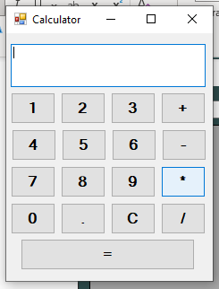

Public Class Form6

Dim Firstnum As Decimal
Dim secondnum As Decimal
Dim Operations As Integer
Dim Operator_Selector As Boolean = False

Private Sub Button1_Click(sender As Object, e As EventArgs) Handles Button1.Click
If TextBox1.Text <> "0" Then
TextBox1.Text += "1"
Else
TextBox1.Text = "1"
End If
End Sub

Private Sub Button2_Click(sender As Object, e As EventArgs) Handles Button2.Click
If TextBox1.Text <> "0" Then
TextBox1.Text += "2"
Else
TextBox1.Text = "2"
End If
End Sub

Private Sub Button3_Click(sender As Object, e As EventArgs) Handles Button3.Click
If TextBox1.Text <> "0" Then
TextBox1.Text += "3"
Else
TextBox1.Text = "3"
End If
End Sub

Private Sub Button8_Click(sender As Object, e As EventArgs) Handles Button8.Click
If TextBox1.Text <> "0" Then
TextBox1.Text += "4"
Else
TextBox1.Text = "4"
End If
End Sub

Private Sub Button7_Click(sender As Object, e As EventArgs) Handles Button7.Click
If TextBox1.Text <> "0" Then
TextBox1.Text += "5"
Else
TextBox1.Text = "5"
End If
End Sub

Private Sub Button6_Click(sender As Object, e As EventArgs) Handles Button6.Click
If TextBox1.Text <> "0" Then
TextBox1.Text += "6"
Else
TextBox1.Text = "6"
End If
End Sub

Private Sub Button12_Click(sender As Object, e As EventArgs) Handles Button12.Click
If TextBox1.Text <> "0" Then
TextBox1.Text += "7"
Else
TextBox1.Text = "7"
End If
End Sub

Private Sub Button11_Click(sender As Object, e As EventArgs) Handles Button11.Click
If TextBox1.Text <> "0" Then
TextBox1.Text += "8"
Else
TextBox1.Text = "8"
End If
End Sub

Private Sub Button10_Click(sender As Object, e As EventArgs) Handles Button10.Click
If TextBox1.Text <> "0" Then
TextBox1.Text += "9"
Else
TextBox1.Text = "9"
End If
End Sub

Private Sub Button16_Click(sender As Object, e As EventArgs) Handles Button16.Click
If TextBox1.Text <> "0" Then
TextBox1.Text += "0"
End If
End Sub

Private Sub Button15_Click(sender As Object, e As EventArgs) Handles Button15.Click
If Not (TextBox1.Text.Contains(".")) Then
TextBox1.Text += "."
End If
End Sub

Private Sub Button14_Click(sender As Object, e As EventArgs) Handles Button14.Click
TextBox1.Text = "0"
End Sub

Private Sub Button4_Click(sender As Object, e As EventArgs) Handles Button4.Click
Firstnum = TextBox1.Text
TextBox1.Text = "0"
Operator_Selector = True
Operations = 1 ' = +
End Sub

Private Sub Button5_Click(sender As Object, e As EventArgs) Handles Button5.Click
Firstnum = TextBox1.Text
TextBox1.Text = "0"
Operator_Selector = True
Operations = 2 ' = -
End Sub

Private Sub Button9_Click(sender As Object, e As EventArgs) Handles Button9.Click
Firstnum = TextBox1.Text
TextBox1.Text = "0"
Operator_Selector = True
Operations = 3 ' = *
End Sub

Private Sub Button13_Click(sender As Object, e As EventArgs) Handles Button13.Click
Firstnum = TextBox1.Text
TextBox1.Text = "0"
Operator_Selector = True
Operations = 4 ' = /
End Sub

Private Sub Button17_Click(sender As Object, e As EventArgs) Handles Button17.Click
If Operator_Selector = True Then
secondnum = TextBox1.Text
If Operations = 1 Then
TextBox1.Text = Firstnum + secondnum
ElseIf Operations = 2 Then
TextBox1.Text = Firstnum - secondnum
ElseIf Operations = 3 Then
TextBox1.Text = Firstnum * secondnum
Else
If secondnum = 0 Then
TextBox1.Text = "Error!"
Else
TextBox1.Text = Firstnum / secondnum
End If
Operator_Selector = False
End If
End If
End Sub
End Class

Using TELERIK UI

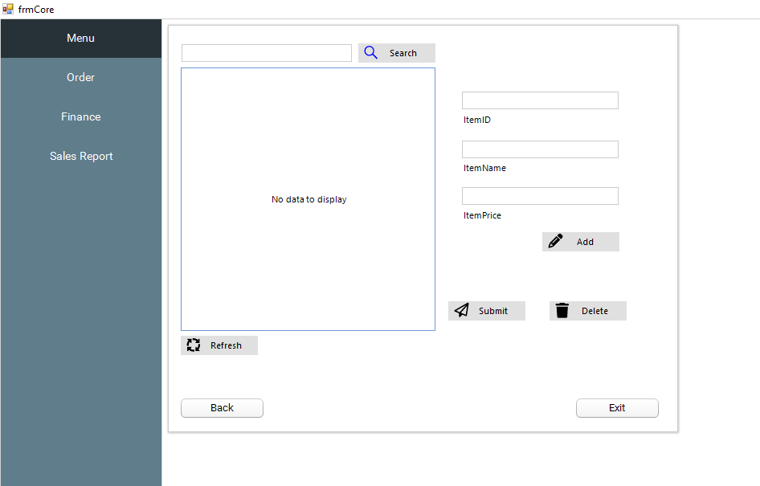
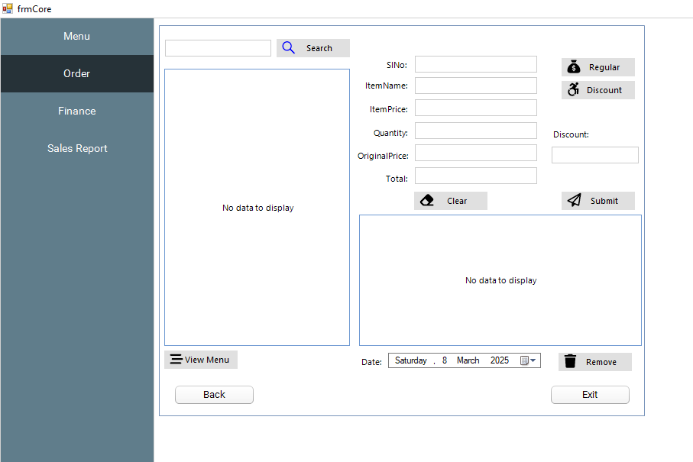
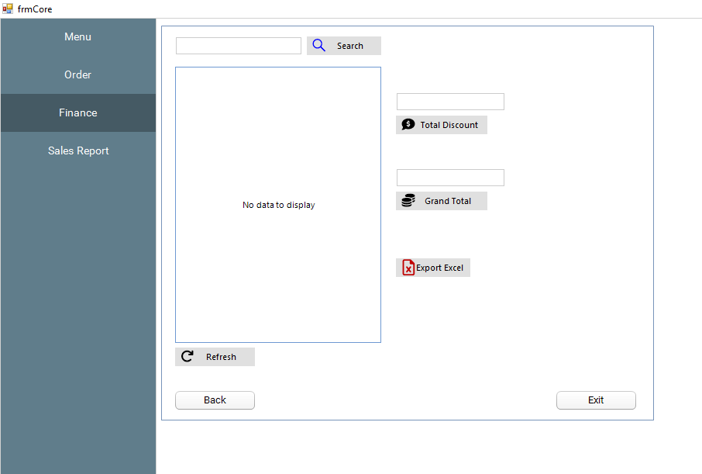
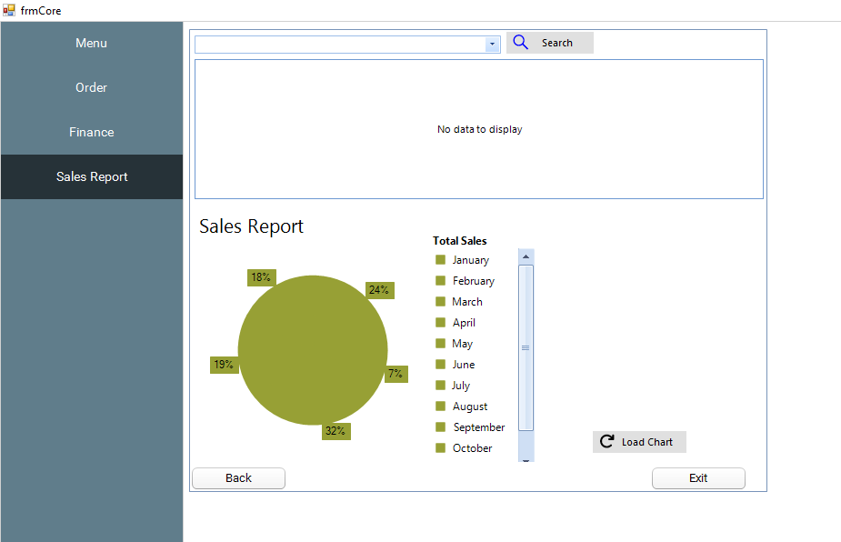
Imports System.IO
Imports Ingres.Client
Imports NPOI.XSSF.UserModel
Imports Telerik.WinControls.UI
Imports System.Data

Public Class frmCore

'Ingres Connection DB
Public IngresKonek As New IngresConnection("host=172.17.243.202;database=ann_hotelreservation_db;user id=ingres;password=71xLR!m3&OPH;tz=philippines;")

'Form Connection to DB
Private Sub frmCore_Load(sender As Object, e As EventArgs) Handles MyBase.Load

IngConn1 = "host=172.17.243.202;database=ann_hotelreservation_db;user id=ingres;password=71xLR!m3&OPH;tz=philippines;"

Call MenuView()
Call OrderDisplay()
Call FinanceDisplay()
Call SalesReport()

Try
Dim output As New DataTable
Dim query As String = "SELECT * FROM tbl_menu"

Using conn As New IngresConnection(IngConn1)
conn.Open()
Using comm As New IngresCommand()
With comm
.Connection = conn
.CommandType = CommandType.Text
.CommandText = query
End With
Dim DTAdapter As New IngresDataAdapter(comm)
DTAdapter.Fill(output)

End Using
conn.Dispose()
conn.Close()
End Using

output.Columns(0).ColumnName = "Code"

RemoveSortOrder(RadComboBox_Search_SalesReport)
RadComboBox_Search_SalesReport.DataSource = output.Copy
RadComboBox_Search_SalesReport.BestFitColumns()
RadComboBox_Search_SalesReport.SelectedIndex = -1

RGV_SalesReport.DataSource = output
RGV_SalesReport.Refresh()

Catch ex As Exception
MsgBox(ex.Message)
End Try

End Sub

Public Sub RemoveSortOrder(ByVal MCB As RadMultiColumnComboBox)
Try
For x = 0 To MCB.Columns.Count - 1
MCB.EditorControl.MasterTemplate.Columns(x).Sort(RadSortOrder.None, True)
Next

Catch ex As Exception
MsgBox(ex.Message)
End Try
End Sub

'Submit function for menu
#Region "Button Submit Menu"
Private Sub Iconbtn_submit_menu_Click(sender As Object, e As EventArgs) Handles Iconbtn_submit_menu.Click
Try
Dim Table As New DataTable
Dim dt As New DataTable
Dim Results As String = "False | Error on saving"

With Table
.Columns.Add("itemid")
.Columns.Add("itemname")
.Columns.Add("itemprice")
End With

Table.Rows.Clear()
Table.Rows.Add(RadTextBox_itemid.Text.ToString.Trim,
RadTextBox_itemname.Text.ToString.Trim,
RadTextBox_itemprice.Text.ToString.Trim)
'dtpdob.Value,

Results = CStr(SavingRecords(Table))

Dim Output As Boolean = False
Dim ErrMessage As String = ""
Output = CBool(Split(Results, "|")(0).ToString())
ErrMessage = Split(Results, "|")(1).ToString()
MsgBox(ErrMessage)

Call MenuView()

Catch ex As Exception

End Try

End Sub
#End Region

'To Display records from RadGridView Menu
#Region "RadGridView_Menu"
Private Sub Rgv_Menu_Click(sender As Object, e As EventArgs) Handles Rgv_Menu.Click
Try
Dim table As New DataTable
Dim x As Integer = Rgv_Menu.CurrentCell.RowIndex

RadTextBox_itemid.Text = Rgv_Menu.Rows(x).Cells(0).Value.ToString.Trim
RadTextBox_itemname.Text = Rgv_Menu.Rows(x).Cells(1).Value.ToString.Trim
RadTextBox_itemprice.Text = Rgv_Menu.Rows(x).Cells(2).Value.ToString.Trim
'dtpdob.Text = DataGridView1.Rows(x).Cells(4).Value
Rgv_Menu.DataSource = table
Catch ex As Exception
MsgBox(ex.Message)
End Try
End Sub
#End Region

'Create Sub Function for MenuView to call the records from DB - used Query
#Region "MenuView"
Public Sub MenuView()
Try
Dim Table As New DataTable
Dim dta_record As New DataTable
Dim query As String = "SELECT * from tbl_menu"

'"SELECT MAX(itemid) + 1 as itemid FROM Menu"

If OpenFSConn() Then

Dim cmd As New IngresCommand
cmd.Connection = IngresKonek
cmd.CommandText = query
cmd.CommandType = CommandType.Text
cmd.Parameters.Clear()
Dim dta As New IngresDataAdapter(cmd)
dta.Fill(Table)
dta_record = Table

dta.Dispose()
CloseFSConn()

End If
Rgv_Menu.DataSource = Table
Rgv_Menu.Refresh()

Catch ex As Exception

End Try
End Sub
#End Region

'Connection from MenuView
#Region "OpenFSconn & CloseFSconn"
Public Function OpenFSConn() As Boolean
Dim Table As New DataTable

Dim IsOpen As Boolean = False

If IngresKonek.State = ConnectionState.Open Then Return True
Try
IngresKonek.Open()
Catch ex As Exception

End Try

If IngresKonek.State = ConnectionState.Open Then
Dim cm As New IngresCommand("set lockmode session where readlock=nolock", IngresKonek)
cm.ExecuteNonQuery()
IsOpen = True
End If
Rgv_Menu.DataSource = Table
Rgv_Menu.Refresh()

Return IsOpen
End Function

Public Sub CloseFSConn()
If IngresKonek.State = ConnectionState.Open Then IngresKonek.Close()
End Sub
#End Region

'Search for Menu using itemname
#Region "Button for Search of Menu"
Private Sub IconBtn_search_menu_Click(sender As Object, e As EventArgs) Handles IconBtn_search_menu.Click
Try
Dim Table As New DataTable
Dim dta_record As New DataTable
Dim query As String = "Select * FROM tbl_menu WHERE itemname Like '%" + RadTextBox_search_menu.Text + "%'"

If OpenFSConn() Then

Dim cmd As New IngresCommand
cmd.Connection = IngresKonek
cmd.CommandText = query
cmd.CommandType = CommandType.Text
cmd.Parameters.Clear()
Dim dta As New IngresDataAdapter(cmd)
dta.Fill(Table)
dta_record = Table

dta.Dispose()
CloseFSConn()

End If
Rgv_Menu.DataSource = Table
Rgv_Menu.Refresh()

Catch ex As Exception

End Try
End Sub

#End Region

'Delete Function for Menu
#Region "Button for Delete of Menu"
Private Sub IconBtn_delete_menu_Click(sender As Object, e As EventArgs) Handles IconBtn_delete_menu.Click
Dim Table As DataTable

Try
Dim x As Integer = Rgv_Menu.CurrentCell.RowIndex

Dim itemid As String = Rgv_Menu.Rows(x).Cells(0).Value.ToString.Trim

Table = IngDataTable_menu("sp_menu_del1",
{"int|" & itemid})

MsgBox("Successfully Deleted")

Catch ex As Exception
MsgBox(ex.Message)
End Try
End Sub

#End Region
Private Sub IconBtn_refresh_menu_Click(sender As Object, e As EventArgs) Handles IconBtn_refresh_menu.Click
Call MenuView()
End Sub

'Auto generate of Max number from Menu
#Region "Button for Add"
Private Sub IconBtn_add_menu_Click(sender As Object, e As EventArgs) Handles IconBtn_add_menu.Click
Call Generate_idnum()
End Sub
#End Region

#Region "Generate Number max"
Private Sub Generate_idnum()
Dim dta_idnum As DataTable
Dim idnum As Integer = 0
Dim newidnum As Integer = 0

dta_idnum = IngDataTableGenNum("sp_menu_sel1",
{})
dta_idnum.AcceptChanges()

For Each row As DataRow In dta_idnum.Rows
If row(0).ToString.Trim = "" Then
idnum = 0
Else
idnum = Int(row(0))
End If
Next

newidnum = idnum + 1
RadTextBox_itemid.Text = newidnum

RadTextBox_itemname.Clear()
RadTextBox_itemprice.Clear()

End Sub

#End Region
Private Sub Radbtn_exit_menu_Click(sender As Object, e As EventArgs) Handles Radbtn_exit_menu.Click
Me.Close()
End Sub

'"<------Order Code------->"

#Region "Button call Order_ViewMenu"
Private Sub IconBtn_view_menu_Click(sender As Object, e As EventArgs) Handles IconBtn_view_menu.Click
Call Order_ViewMenu()
End Sub
#End Region

'Create Sub ViewMenu
#Region "Create Sub for View Menu"
Public Sub Order_ViewMenu()
Try
Dim Table As New DataTable
Dim dta_record As New DataTable
Dim query As String = "SELECT * FROM tbl_menu"

If OpenFSConn() Then

Dim cmd As New IngresCommand
cmd.Connection = IngresKonek
cmd.CommandText = query
cmd.CommandType = CommandType.Text
cmd.Parameters.Clear()
Dim dta As New IngresDataAdapter(cmd)
dta.Fill(Table)
dta_record = Table

dta.Dispose()
CloseFSConn()

End If
Rgv_viewmenu_order.DataSource = Table
Rgv_viewmenu_order.Refresh()

Catch ex As Exception
MsgBox(ex.Message)
End Try
End Sub
#End Region

'Search Button - Order
#Region "Button Search for Order_ViewMenu"
Private Sub IconBtn_search_order_Click(sender As Object, e As EventArgs) Handles IconBtn_search_order.Click
Try
Dim Table As New DataTable
Dim dta_record As New DataTable
Dim query As String = "Select * FROM tbl_menu WHERE itemname Like '%" + RadTextBox_search_order.Text + "%'"

If OpenFSConnOrder() Then
Dim cmd As New IngresCommand
cmd.Connection = IngresKonek
cmd.CommandText = query
cmd.CommandType = CommandType.Text
cmd.Parameters.Clear()
Dim dta As New IngresDataAdapter(cmd)
dta.Fill(Table)
dta_record = Table

dta.Dispose()
CloseFSConnOrder()

End If

Rgv_Menu.DataSource = Table
Rgv_Menu.Refresh()

Catch ex As Exception
MsgBox(ex.Message)
End Try
End Sub
#End Region

'Connection from Order_MenuView
#Region "OpenFSconnOrder & CloseFSconnOrder"
Public Function OpenFSConnOrder() As Boolean
Dim Table As New DataTable

Dim IsOpen As Boolean = False

If IngresKonek.State = ConnectionState.Open Then Return True
Try
IngresKonek.Open()
Catch ex As Exception

End Try

If IngresKonek.State = ConnectionState.Open Then
Dim cm As New IngresCommand("set lockmode session where readlock=nolock", IngresKonek)
cm.ExecuteNonQuery()
IsOpen = True
End If
Rgv_Menu.DataSource = Table
Rgv_Menu.Refresh()

Return IsOpen
End Function

Public Sub CloseFSConnOrder()
If IngresKonek.State = ConnectionState.Open Then IngresKonek.Close()
End Sub

Private Sub IconBtn_submit_order_Click(sender As Object, e As EventArgs) Handles IconBtn_submit_order.Click
Try
Dim Table As New DataTable
Dim Results As String = "False | Error on saving"

With Table
.Columns.Add("SINo")
.Columns.Add("itemname")
.Columns.Add("itemprice")
.Columns.Add("quantity")
.Columns.Add("originalprice")
.Columns.Add("total")
.Columns.Add("discount")
.Columns.Add("date")
End With

Table.Rows.Clear()
Table.Rows.Add(RadTextBox_SINo_order.Text.ToString.Trim,
RadTextBox_itemname_order.Text.ToString.Trim,
RadTextBox_itemprice_order.Text.ToString.Trim,
RadTextBox_quantity_order.Text.ToString.Trim,
RadTextBox_originalprice_order.Text.ToString.Trim,
RadTextBox_total_order.Text.ToString.Trim,
RadTextBox_discount_order.Text.ToString.Trim,
dtpdate.Value)

Results = CStr(SavingRecords2(Table))

Dim Output As Boolean = False
Dim ErrMessage As String = ""
Output = CBool(Split(Results, "|")(0).ToString())
ErrMessage = Split(Results, "|")(1).ToString()
MsgBox(ErrMessage)
Catch ex As Exception
MsgBox(ex.Message)
End Try
End Sub
#End Region

#Region "Button Clear"
Private Sub IconBtn_clear_order_Click(sender As Object, e As EventArgs) Handles IconBtn_clear_order.Click
RadTextBox_SINo_order.Clear()
RadTextBox_itemname_order.Clear()
RadTextBox_itemprice_order.Clear()
RadTextBox_quantity_order.Clear()
RadTextBox_originalprice_order.Clear()
RadTextBox_total_order.Clear()
RadTextBox_discount_order.Clear()
End Sub
#End Region

#Region "Computation"
Private Sub Iconbtn_regular_order_Click(sender As Object, e As EventArgs) Handles Iconbtn_regular_order.Click
RadTextBox_total_order.Text = (Val(RadTextBox_itemprice_order.Text) * Val(RadTextBox_quantity_order.Text)) * (1 - 0.2)
RadTextBox_discount_order.Text = (Val(RadTextBox_itemprice_order.Text) * Val(RadTextBox_quantity_order.Text)) * (0.2)
End Sub

Private Sub IconBtn_discount_order_Click(sender As Object, e As EventArgs) Handles IconBtn_discount_order.Click
RadTextBox_total_order.Text = (Val(RadTextBox_itemprice_order.Text) * Val(RadTextBox_quantity_order.Text)) * (1 - 0.15)
RadTextBox_discount_order.Text = (Val(RadTextBox_itemprice_order.Text) * Val(RadTextBox_quantity_order.Text)) * (0.15)
End Sub

Private Sub QuantityCompute(sender As Object, e As EventArgs) Handles RadTextBox_quantity_order.TextChanged
If Not IsNumeric(RadTextBox_quantity_order.Text) Then
RadTextBox_quantity_order.Clear()
End If

RadTextBox_total_order.Text = Val(RadTextBox_itemprice_order.Text) * Val(RadTextBox_quantity_order.Text)
RadTextBox_originalprice_order.Text = Val(RadTextBox_itemprice_order.Text) * Val(RadTextBox_quantity_order.Text)
End Sub
#End Region

#Region "Select into RadGridView-MenuView"
Private Sub Rgv_viewmenu_order_Click(sender As Object, e As EventArgs) Handles Rgv_viewmenu_order.Click
Try
Dim table As New DataTable
Dim x As Integer = Rgv_viewmenu_order.CurrentCell.RowIndex

RadTextBox_SINo_order.Text = Rgv_viewmenu_order.Rows(x).Cells(0).Value.ToString.Trim
RadTextBox_itemname_order.Text = Rgv_viewmenu_order.Rows(x).Cells(1).Value.ToString.Trim
RadTextBox_itemprice_order.Text = Rgv_viewmenu_order.Rows(x).Cells(2).Value.ToString.Trim
Rgv_viewmenu_order.DataSource = table
Catch ex As Exception
MsgBox(ex.Message)
End Try
End Sub
#End Region

#Region "RadGridView-Order"
Private Sub Rgv_order_Click(sender As Object, e As EventArgs) Handles Rgv_order.Click
Try
Dim x As Integer = Rgv_order.CurrentCell.RowIndex

RadTextBox_SINo_order.Text = Rgv_order.Rows(x).Cells(0).Value.ToString().Trim
RadTextBox_itemname_order.Text = Rgv_order.Rows(x).Cells(1).Value.ToString().Trim
RadTextBox_itemprice_order.Text = Rgv_order.Rows(x).Cells(2).Value.ToString().Trim
RadTextBox_quantity_order.Text = Rgv_order.Rows(x).Cells(3).Value.ToString().Trim
RadTextBox_originalprice_order.Text = Rgv_order.Rows(x).Cells(4).Value.ToString().Trim
RadTextBox_total_order.Text = Rgv_order.Rows(x).Cells(5).Value.ToString().Trim
RadTextBox_discount_order.Text = Rgv_order.Rows(x).Cells(6).Value.ToString().Trim
dtpdate.Text = Rgv_order.Rows(x).Cells(7).Value

Catch ex As Exception
MsgBox(ex.Message)
End Try
End Sub
#End Region

#Region "OrderDisplay"
Private Sub OrderDisplay()
Try
Dim Table As New DataTable
Dim dta_record As New DataTable
Dim query As String = "SELECT * FROM tbl_order"

If OpenFSConn() Then

Dim cmd As New IngresCommand
cmd.Connection = IngresKonek
cmd.CommandText = query
cmd.CommandType = CommandType.Text
cmd.Parameters.Clear()
Dim dta As New IngresDataAdapter(cmd)
dta.Fill(Table)
dta_record = Table

dta.Dispose()
CloseFSConn()

End If
Rgv_order.DataSource = Table
Rgv_order.Refresh()

Catch ex As Exception

End Try
End Sub
#End Region

'"<------Finance Code------->"

#Region "Button Search Finance"
Private Sub Iconbtn_search_finance_Click(sender As Object, e As EventArgs) Handles Iconbtn_search_finance.Click
Try
Dim Table As New DataTable
Dim dta_record As New DataTable
Dim query As String = "Select * FROM tbl_order WHERE itemname Like '%" + RadTextBox_search_finance.Text + "%'"

If OpenFSConn() Then

Dim cmd As New IngresCommand
cmd.Connection = IngresKonek
cmd.CommandText = query
cmd.CommandType = CommandType.Text
cmd.Parameters.Clear()
Dim dta As New IngresDataAdapter(cmd)
dta.Fill(Table)
dta_record = Table

dta.Dispose()
CloseFSConn()

End If
Rgv_finance.DataSource = Table
Rgv_finance.Refresh()

Catch ex As Exception
MsgBox(ex.Message)
End Try
End Sub
#End Region

#Region "RadGridView Finance"
Private Sub Rgv_finance_Click(sender As Object, e As EventArgs) Handles Rgv_finance.Click
Dim x As Integer = Rgv_finance.CurrentCell.RowIndex

RadTextBox_SINo_order.Text = Rgv_finance.Rows(x).Cells(0).Value.ToString().Trim
RadTextBox_itemname_order.Text = Rgv_finance.Rows(x).Cells(1).Value.ToString().Trim
RadTextBox_itemprice_order.Text = Rgv_finance.Rows(x).Cells(2).Value.ToString().Trim
RadTextBox_quantity_order.Text = Rgv_finance.Rows(x).Cells(3).Value.ToString().Trim
RadTextBox_originalprice_order.Text = Rgv_finance.Rows(x).Cells(4).Value.ToString().Trim
RadTextBox_total_order.Text = Rgv_finance.Rows(x).Cells(5).Value.ToString().Trim
RadTextBox_discount_order.Text = Rgv_finance.Rows(x).Cells(6).Value.ToString().Trim
dtpdate.Text = Rgv_finance.Rows(x).Cells(7).Value
End Sub
#End Region

#Region "Finance Display"
Private Sub FinanceDisplay()
Try
Dim Table As New DataTable
Dim dta_record As New DataTable
Dim query As String = "SELECT * FROM tbl_order"

If OpenFSConn() Then

Dim cmd As New IngresCommand
cmd.Connection = IngresKonek
cmd.CommandText = query
cmd.CommandType = CommandType.Text
cmd.Parameters.Clear()
Dim dta As New IngresDataAdapter(cmd)
dta.Fill(Table)
dta_record = Table

dta.Dispose()
CloseFSConn()

End If
Rgv_finance.DataSource = Table
Rgv_finance.Refresh()

Catch ex As Exception
MsgBox(ex.Message)
End Try
End Sub
#End Region

#Region "Total Discount"
Private Sub IconBtn_totaldiscount_finance_Click(sender As Object, e As EventArgs) Handles IconBtn_totaldiscount_finance.Click
Dim SUM As Integer

For i As Integer = 0 To Rgv_finance.RowCount - 1

SUM += Rgv_finance.Rows(i).Cells(6).Value
Next
RadTextBox_totdiscount_finance.Text = SUM.ToString
End Sub

Private Sub Iconbtn_grandtotal_finance_Click(sender As Object, e As EventArgs) Handles Iconbtn_grandtotal_finance.Click
Dim SUM As Integer

For i As Integer = 0 To Rgv_finance.RowCount - 1

SUM += Rgv_finance.Rows(i).Cells(5).Value
Next
RadTextBox_grandtotal_finance.Text = SUM.ToString

End Sub

#End Region

Private Sub IconBtn_Refresh_Click(sender As Object, e As EventArgs) Handles IconBtn_Refresh.Click
Call FinanceDisplay()
End Sub

Private Sub IconBtn_export_finance_Click(sender As Object, e As EventArgs) Handles IconBtn_export_finance.Click
Try
Dim worker As New System.ComponentModel.BackgroundWorker
AddHandler worker.DoWork, AddressOf ExportLoad
AddHandler worker.RunWorkerCompleted, AddressOf ExportCompleted
worker.RunWorkerAsync()
Catch ex As Exception
MsgBox(ex.Message)
End Try
End Sub

Private Sub ExportCompleted(ByVal sender As System.Object, ByVal e As System.ComponentModel.RunWorkerCompletedEventArgs)
Dim Result As ResultExporXYZ = e.Result

If Result.isSuccess = True Then
Dim SaveDialog As New SaveFileDialog
SaveDialog.Title = "Save Report"

SaveDialog.Filter = "Excel Files|*.xlsx"
SaveDialog.FilterIndex = 1
If SaveDialog.ShowDialog = DialogResult.OK Then
Try
Dim xlFileName As String = SaveDialog.FileName

Dim xfile As New FileStream(SaveDialog.FileName, FileMode.Create, System.IO.FileAccess.Write)
Result.hssfwb.Write(xfile)
xfile.Close()
Process.Start(SaveDialog.FileName)
Catch ex As Exception
MsgBox(ex.Message)
End Try
End If
End If
End Sub

Public Structure ResultExporXYZ
Dim isSuccess As Boolean
Dim hssfwb As XSSFWorkbook
End Structure
Private Sub ExportLoad(ByVal sender As System.Object, ByVal e As System.ComponentModel.DoWorkEventArgs)
Dim Result As New ResultExporXYZ

Result.isSuccess = False
Try
Dim hssfwb = New XSSFWorkbook(NPOI.OpenXml4Net.OPC.OPCPackage.Open(New MemoryStream(My.Resources.template1)))

Dim formatSheet As XSSFSheet = hssfwb.GetSheet("Sheet1")
Dim copyrow As XSSFRow = formatSheet.GetRow(0)
Dim begincounter As Integer = 1

For X As Integer = 0 To Rgv_finance.Rows.Count - 1
copyrow.CopyRowTo(begincounter)
Dim cellrow As XSSFRow = formatSheet.GetRow(begincounter)
cellrow.GetCell(0).SetCellValue(Rgv_finance.Rows(X).Cells(0).Value.ToString)
cellrow.GetCell(1).SetCellValue(Rgv_finance.Rows(X).Cells(1).Value.ToString)
cellrow.GetCell(2).SetCellValue(Rgv_finance.Rows(X).Cells(2).Value.ToString)
cellrow.GetCell(3).SetCellValue(Rgv_finance.Rows(X).Cells(3).Value.ToString)
cellrow.GetCell(4).SetCellValue(Rgv_finance.Rows(X).Cells(4).Value.ToString)
cellrow.GetCell(5).SetCellValue(Rgv_finance.Rows(X).Cells(5).Value.ToString)
cellrow.GetCell(6).SetCellValue(Rgv_finance.Rows(X).Cells(6).Value.ToString)
cellrow.GetCell(7).SetCellValue(Rgv_finance.Rows(X).Cells(7).Value.ToString)

begincounter += 1
Next

Result.hssfwb = hssfwb
Result.isSuccess = True
Catch ex As Exception
MsgBox(ex.Message)
End Try
e.Result = Result
End Sub

Private Sub SalesReport()
Try
Dim Table As New DataTable
Dim dta_record As New DataTable
Dim query As String = "SELECT a.itemid, a.itemname, a.itemprice, b.quantity, b.originalprice, b.total, b.discount, b.date
FROM tbl_menu a LEFT JOIN tbl_order b ON a.itemid = b.sino"

If OpenFSConn() Then

Dim cmd As New IngresCommand
cmd.Connection = IngresKonek
cmd.CommandText = query
cmd.CommandType = CommandType.Text
cmd.Parameters.Clear()
Dim dta As New IngresDataAdapter(cmd)
dta.Fill(Table)
dta_record = Table

dta.Dispose()
CloseFSConn()

End If
RGV_SalesReport.DataSource = Table
RGV_SalesReport.Refresh()

Catch ex As Exception
MsgBox(ex.Message)
End Try
End Sub

Private Sub RGV_SalesReport_Click(sender As Object, e As EventArgs) Handles RGV_SalesReport.Click
Dim x As Integer = RGV_SalesReport.CurrentCell.RowIndex

RadTextBox_itemid.Text = RGV_SalesReport.Rows(x).Cells(0).Value.ToString().Trim
RadTextBox_itemname.Text = RGV_SalesReport.Rows(x).Cells(1).Value.ToString().Trim
RadTextBox_itemprice.Text = RGV_SalesReport.Rows(x).Cells(2).Value.ToString().Trim
RadTextBox_quantity_order = RGV_SalesReport.Rows(x).Cells(3).Value
RadTextBox_originalprice_order = RGV_SalesReport.Rows(x).Cells(4).Value
RadTextBox_total_order = RGV_SalesReport.Rows(x).Cells(5).Value
RadTextBox_discount_order = RGV_SalesReport.Rows(x).Cells(6).Value

End Sub

Private Sub IconButton5_Click(sender As Object, e As EventArgs) Handles IconBtn_Search_SalesReport.Click
Dim Table As New DataTable

Dim query As String = "SELECT a.itemid, a.itemname, a.itemprice, b.quantity, b.originalprice, b.total, b.discount, b.date
FROM tbl_menu a LEFT JOIN tbl_order b ON a.itemid = b.sino
WHERE a.itemid Like '%" + RadComboBox_Search_SalesReport.Text + "%'"

Try
If OpenFSConn() Then

Dim cmd As New IngresCommand
cmd.Connection = IngresKonek
cmd.CommandText = query
cmd.CommandType = CommandType.Text
cmd.Parameters.Clear()
Dim dta As New IngresDataAdapter(cmd)
dta.Fill(Table)
dta_record = Table

dta.Dispose()
CloseFSConn()

End If
RGV_SalesReport.DataSource = Table
RGV_SalesReport.Refresh()

Catch ex As Exception
MsgBox(ex.Message)
End Try
End Sub

Private Sub IconBtn_LoadChart_SalesReport_Click(sender As Object, e As EventArgs, dr As DataTable) Handles IconBtn_LoadChart_SalesReport.Click
Try
Dim output As New DataTable
Dim Table As New DataTable
Dim query As String = "SELECT total, date FROM tbl_order "

If OpenFSConn() Then

Dim cmd As New IngresCommand
cmd.Connection = IngresKonek
cmd.CommandText = query
cmd.CommandType = CommandType.Text
cmd.Parameters.Clear()
Dim dta As New IngresDataAdapter(cmd)
dta.Fill(Table)
dta_record = Table

dta.Dispose()
CloseFSConn()
End If

'RadChart_SalesReport "date".XValueMember = "date"
'RadChart_SalesReport "total".YValueMember = "total"

RGV_SalesReport.Rows.Clear()
RadChart_SalesReport.DataSource = output
RadChart_SalesReport.Refresh()

Catch ex As Exception
MsgBox(ex.Message)
End Try
End Sub

Private Sub RadButton1_Click(sender As Object, e As EventArgs)
Me.Close()
End Sub

End Class

MODULE

Imports Ingres.Client

Module Module1
Public IngConn1 As String
Dim ConnIngres As New IngresConnection
Dim ComIngres As New IngresCommand
Dim dr As New IngresDataAdapter
Dim OutputTable As New DataTable

'For Submit connection of SavingRecords "Submit records from the DB(Menu)"
#Region "Saving Records (Menu)"
Public Function SavingRecords(ByVal table As DataTable) As String
Dim Output As Boolean = False

Dim ErrMessage As String = "Error on saving person."

Dim OracleIntegIngresConn As New IngresConnection
OracleIntegIngresConn.ConnectionString = IngConn1
Dim OracleIntegIngresComm As New IngresCommand
Dim OracleIntegIngresTrans_JournalEntry As IngresTransaction = Nothing
Dim OracleIntegIngresDReader As IngresDataReader

Dim IngFields() As String = {}
Try
OracleIntegIngresConn.Open()
ExecuteReadLockSession(OracleIntegIngresConn)
OracleIntegIngresTrans_JournalEntry = OracleIntegIngresConn.BeginTransaction
OracleIntegIngresComm.Connection = OracleIntegIngresConn
OracleIntegIngresComm.Transaction = OracleIntegIngresTrans_JournalEntry

For Each items In table.AsEnumerable()
With OracleIntegIngresComm
.Parameters.Clear()
.CommandText = "sp_menu_ins"
.CommandType = Data.CommandType.StoredProcedure
End With

IngFields = {"int|" & items.ItemArray(0).ToString.Trim,
"var|" & items.ItemArray(1).ToString.Trim,
"var|" & items.ItemArray(2).ToString.Trim}

'"dte|" & items.ItemArray(4),

SetParameters(OracleIntegIngresComm, IngFields)
OracleIntegIngresDReader = OracleIntegIngresComm.ExecuteReader
If Not OracleIntegIngresDReader.IsClosed Then OracleIntegIngresDReader.Close()
Next
OracleIntegIngresTrans_JournalEntry.Commit()
Output = True
ErrMessage = "New Information has been saved."

Catch ex As Exception
If ErrMessage = "Error on saving Information." Then
ErrMessage = "Error on saving Information." & ex.Message
End If
OracleIntegIngresTrans_JournalEntry.Rollback()
Finally
OracleIntegIngresConn.Close()
OracleIntegIngresConn.Dispose()
OracleIntegIngresComm.Dispose()
End Try
Return Output & "|" & ErrMessage
End Function

Public Sub ExecuteReadLockSession(ByVal IngConn1 As IngresConnection)
Dim IngresCm As New IngresCommand("set lockmode session where readlock=nolock", IngConn1)
If IngConn1.State = ConnectionState.Open Then
IngresCm.ExecuteNonQuery()
End If
IngresCm.Dispose()
End Sub
Public Function SetParameters(ByRef Input As IngresCommand, ByVal ParamArray IngFields() As String) As Boolean
Dim Result As Boolean = True
Try
For i = 0 To UBound(IngFields)
Dim StrDataType As String = IngFields(i).Split(CChar("|")).GetValue(0).ToString
Dim StrValue As String = IngFields(i).Split(CChar("|")).GetValue(1).ToString
Select Case StrDataType.ToUpper
Case Is = "INT"
Input.Parameters.Add("Parameter" & i, IngresType.Int).Value = CInt(StrValue)
Case Is = "VAR"
Input.Parameters.Add("Parameter" & i, IngresType.VarChar).Value = StrValue
Case Is = "CHR"
Input.Parameters.Add("Parameter" & i, IngresType.Char).Value = StrValue
Case Is = "DTE"
Input.Parameters.Add("Parameter" & i, IngresType.Date).Value = CDate(StrValue)
Case Is = "MON"
Input.Parameters.Add("Parameter" & i, IngresType.Double).Value = CDbl(StrValue)
End Select
Next
Catch ex As Exception
Result = False
End Try
Return Result
End Function

#End Region

'For Submit connection of SavingRecords2 "Submit records from the DB(Order)"
#Region "Saving Records (Order)"
Public Function SavingRecords2(ByVal table As DataTable) As String
Dim Output As Boolean = False

Dim ErrMessage As String = "Error on saving person."

Dim OracleIntegIngresConn As New IngresConnection
OracleIntegIngresConn.ConnectionString = IngConn1
Dim OracleIntegIngresComm As New IngresCommand
Dim OracleIntegIngresTrans_JournalEntry As IngresTransaction = Nothing
Dim OracleIntegIngresDReader As IngresDataReader

Dim IngFields() As String = {}
Try
OracleIntegIngresConn.Open()
ExecuteReadLockSession(OracleIntegIngresConn)
OracleIntegIngresTrans_JournalEntry = OracleIntegIngresConn.BeginTransaction
OracleIntegIngresComm.Connection = OracleIntegIngresConn
OracleIntegIngresComm.Transaction = OracleIntegIngresTrans_JournalEntry

For Each items In table.AsEnumerable()
With OracleIntegIngresComm
.Parameters.Clear()
.CommandText = "sp_order_ins1"
.CommandType = Data.CommandType.StoredProcedure
End With

IngFields = {"int|" & items.ItemArray(0).ToString.Trim,
"var|" & items.ItemArray(1).ToString.Trim,
"var|" & items.ItemArray(2).ToString.Trim,
"int|" & items.ItemArray(3).ToString.Trim,
"var|" & items.ItemArray(4).ToString.Trim,
"var|" & items.ItemArray(5).ToString.Trim,
"var|" & items.ItemArray(6).ToString.Trim,
"dte|" & items.ItemArray(7)}

SetParameters(OracleIntegIngresComm, IngFields)
OracleIntegIngresDReader = OracleIntegIngresComm.ExecuteReader
If Not OracleIntegIngresDReader.IsClosed Then OracleIntegIngresDReader.Close()
Next
OracleIntegIngresTrans_JournalEntry.Commit()
Output = True
ErrMessage = "New Information has been saved."

Catch ex As Exception
If ErrMessage = "Error on saving Information." Then
ErrMessage = "Error on saving Information." & ex.Message
End If
OracleIntegIngresTrans_JournalEntry.Rollback()
Finally
OracleIntegIngresConn.Close()
OracleIntegIngresConn.Dispose()
OracleIntegIngresComm.Dispose()
End Try
Return Output & "|" & ErrMessage
End Function
#End Region

#Region "Delete function for Menu"
Public Function IngDataTable_menu(ByVal ProcedureName As String, ByVal ParamArray IngFields() As String) As DataTable
Dim ConnIngres As New IngresConnection
Dim ComIngres As New IngresCommand
Dim dr As New IngresDataAdapter
Dim OutputTable As New DataTable

Try
ConnIngres.ConnectionString = IngConn1
ConnIngres.Open()
ExecuteReadLockSession(ConnIngres)

With ComIngres
.Connection = ConnIngres
.Parameters.Clear()
.CommandText = "sp_menu_del1"
.CommandType = Data.CommandType.StoredProcedure
End With

For i = 0 To UBound(IngFields)
Dim StrDataType As String = IngFields(i).Split("|").GetValue(0)
Dim StrValue As String = IngFields(i).Split("|").GetValue(1)
Select Case StrDataType.ToUpper
Case Is = "INT"
ComIngres.Parameters.Add("Parameter" & i, IngresType.Int).Value = CInt(StrValue)
Case Is = "VAR"
ComIngres.Parameters.Add("Parameter" & i, IngresType.VarChar).Value = StrValue
Case Is = "CHR"
ComIngres.Parameters.Add("Parameter" & i, IngresType.Char).Value = StrValue
Case Is = "DTE"
ComIngres.Parameters.Add("Parameter" & i, IngresType.Date).Value = CDate(StrValue)
Case Is = "MON"
ComIngres.Parameters.Add("Parameter" & i, IngresType.Double).Value = CDbl(StrValue)
End Select
Next

dr.SelectCommand = ComIngres
dr.Fill(OutputTable)
Catch x As Exception
Console.Write(x.Message.ToString)
ComIngres.Dispose()
Finally
ConnIngres.Close()
ConnIngres.Dispose()
dr.Dispose()
ComIngres.Dispose()
End Try

For x = 0 To OutputTable.Columns.Count - 1
OutputTable.Columns(x).ColumnName = "result element" & x
Next

Return OutputTable
End Function
#End Region

#Region "Generate Number Max"
Public Function IngDataTableGenNum(ByVal ProcedureName As String, ByVal ParamArray IngFields() As String) As DataTable
Dim ConnIngres As New IngresConnection
Dim ComIngres As New IngresCommand
Dim dr As New IngresDataAdapter
Dim OutputTable As New DataTable

Try
ConnIngres.ConnectionString = IngConn1
ConnIngres.Open()
ExecuteReadLockSession(ConnIngres)

With ComIngres
.Connection = ConnIngres
.Parameters.Clear()
.CommandText = "sp_menu_sel1"
.CommandType = Data.CommandType.StoredProcedure
End With

For i = 0 To UBound(IngFields)
Dim StrDataType As String = IngFields(i).Split("|").GetValue(0)
Dim StrValue As String = IngFields(i).Split("|").GetValue(1)
Select Case StrDataType.ToUpper
Case Is = "INT"
ComIngres.Parameters.Add("Parameter" & i, IngresType.Int).Value = CInt(StrValue)
Case Is = "VAR"
ComIngres.Parameters.Add("Parameter" & i, IngresType.VarChar).Value = StrValue
Case Is = "CHR"
ComIngres.Parameters.Add("Parameter" & i, IngresType.Char).Value = StrValue
Case Is = "DTE"
ComIngres.Parameters.Add("Parameter" & i, IngresType.Date).Value = CDate(StrValue)
Case Is = "MON"
ComIngres.Parameters.Add("Parameter" & i, IngresType.Double).Value = CDbl(StrValue)
End Select
Next

dr.SelectCommand = ComIngres
dr.Fill(OutputTable)
Catch x As Exception
Console.Write(x.Message.ToString)
ComIngres.Dispose()
Finally
ConnIngres.Close()
ConnIngres.Dispose()
dr.Dispose()
ComIngres.Dispose()
End Try

For x = 0 To OutputTable.Columns.Count - 1
OutputTable.Columns(x).ColumnName = "result element" & x
Next

Return OutputTable
End Function
#End Region

End Module

