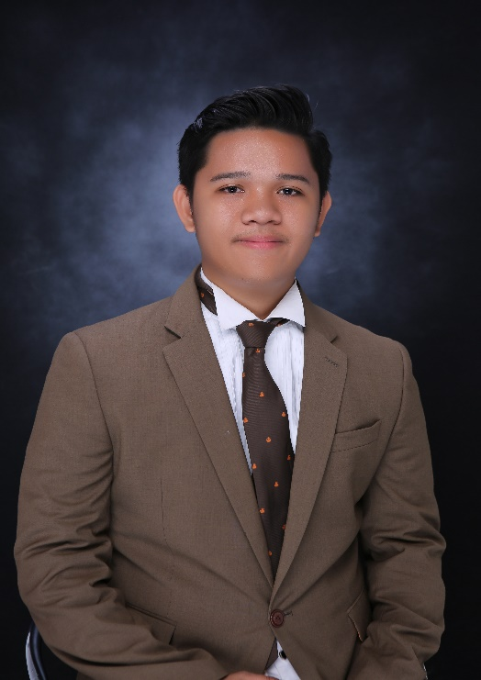**MICHAEL NIÑO C. SEGUISABAL**

**Phone** : 09229488813

**E-mail** : [michaelninoseguisabal@gmail.com](mailto:michaelninoseguisabal@gmail.com)

**Address** : Poblacion, Compostela, Cebu

**Birthday** : November 08, 1998

**CAREER OBJECTIVES**

Secure a position in a creative and dynamic work environment where I can apply my skills in Sales Marketing and in Computer Technologies both hardware and software.

**TECHNICAL SKILLS**

* Microsoft Office Literate
* Computer Hardware Suit
* Basic Webpage Designing Skills
* Computer hardware/software troubleshooting skills
* Basic Graphic Designing Skills
* Adobe Photoshop and Adobe Illustrator literate
* Sales Marketing Skills

**PERSONAL SKILLS**

* Excellent time management skills
* Strong impersonal and communication skills
* Analytical and excellent problem-solving skills
* Extremely organized and detail oriented
* Position Based Skills
* Leadership Skills

**EDUCATION**

**Cebu Technological University-Danao Campus (2018-2019)**

Bachelor of Science in Industrial Technology Major in Computer

Sabang, Danao City

**Compostela National Highschool (2014-2015)**

Poblacion, Compostela Cebu

**Compostela Central School (2010-2011)**

Cogon, Compostela Cebu

**WORK EXPERIENCES**

**Computer Technician/Sales Representative (On the Job Training)**

**HT Computer Supply and Services**

Pakna-an, Mandaue City, Cebu

June 01, 2018 – March 15, 2019

**JOB DESCRIPTIONS:**

* Troubleshooting Hardware and Software Issues of computer
* Computer Assembly
* CCTV Installation
* Photo and video editing for product
* Checking Inventory of items
* Computer Networking

**Sales Associate/Cashier**

**iTECH Ventures**

SM City Cebu, North Reclamation Area, Cebu City, Cebu

July 01, 2020 – Present

**JOB DESCRIPTIONS:**

* Promoting and selling computer products
* Computer Assembly
* Assist Online Inquiries through Facebook page
* Checking Inventory of items
* Cashiering
* Assisting Costumer Complaints about a certain product

**CHARACTER REFERENCES**

**Mr. Arnel Parpado**

Supervisor

09175339020

HT Computer Supply and Services

**Mrs. Aireen Encorporado**

Senior Team Leader

09190655980

iTECH SM Cebu