|  |
| --- |
| **HAGOP Y. SARKISSIAN, M.D.** |
| *Internal Medicine Board Certified*  hysarkis@yahoo.com  818-415-1439 |
| 13885 Siena Loop, Lakewood Ranch, FL 34202 |
|  |
|  |
|  |
|  |

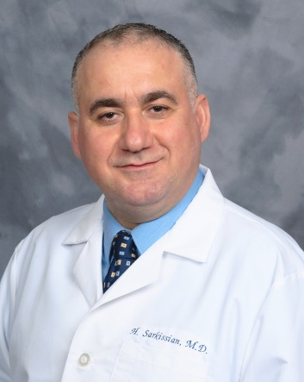

EXPERIENCE / WORK / TRAINING

**VES Multi-State**

*Veterans Evaluation Services 05/2023 – Present*

**Signify Health Multi-State**

*In Home and Virtual Care 12/2022 – Present*

**Village Medical Sarasota, FL**

*Primary Care Clinic 08/2022 - Present*

**Healthcare Partners / Optum Chatsworth, CA**

*Skilled Nursing Facility / Hospitalist 04/2016 – 07/2022*

**Los Angeles County Los Angeles, CA**

*Primary Care and HIV clinic 03/2006 – 08/2021*

**Good Samaritan Hospital Los Angeles, CA**

*Hospitalist 11/2006 – 10/2016*

**USC Keck School of Medicine Los Angeles, CA**

*Correctional HIV Fellowship 10/2010 - 09/2011*

**Kaiser Permanente Panorama City, CA**

*Urgent Care 12/2005 - 03/2013*

**Primary Care Los Angeles, CA**

*Medical Clinic 07/2000 - 11/2006*

**Lutheran Medical Center Brooklyn, NY**

*Internal Medicine Intern/Resident 07/1997 - 06/2000*

**Volunteer Los Angeles, CA**

*Heartbeat Cardiovascular Medical Clinic 04/1993 - 06/1997*

**Primary Care Aleppo, Syria**

*Family Health and Wellness Center 07/1990 - 03/1993*

Education

**Yerevan State Medical University Yerevan, Armenia**

*Doctor of Medicine 09/1984 - 06/1990*

**Guiliguian College Aleppo / Syria**

*Bachelor of Science 09/1982 -* 07/1984

LICENSURE & Certifications

**Licensed in Florida, California, Nevada, Hawaii**

**MAT Waiver / American Academy of Addiction Psychiatry**

**HIV Medicine / University of Southern California**

EXAMINATIONS

**American Board of Internal Medicine** 2000 & 2010 & Present LKA