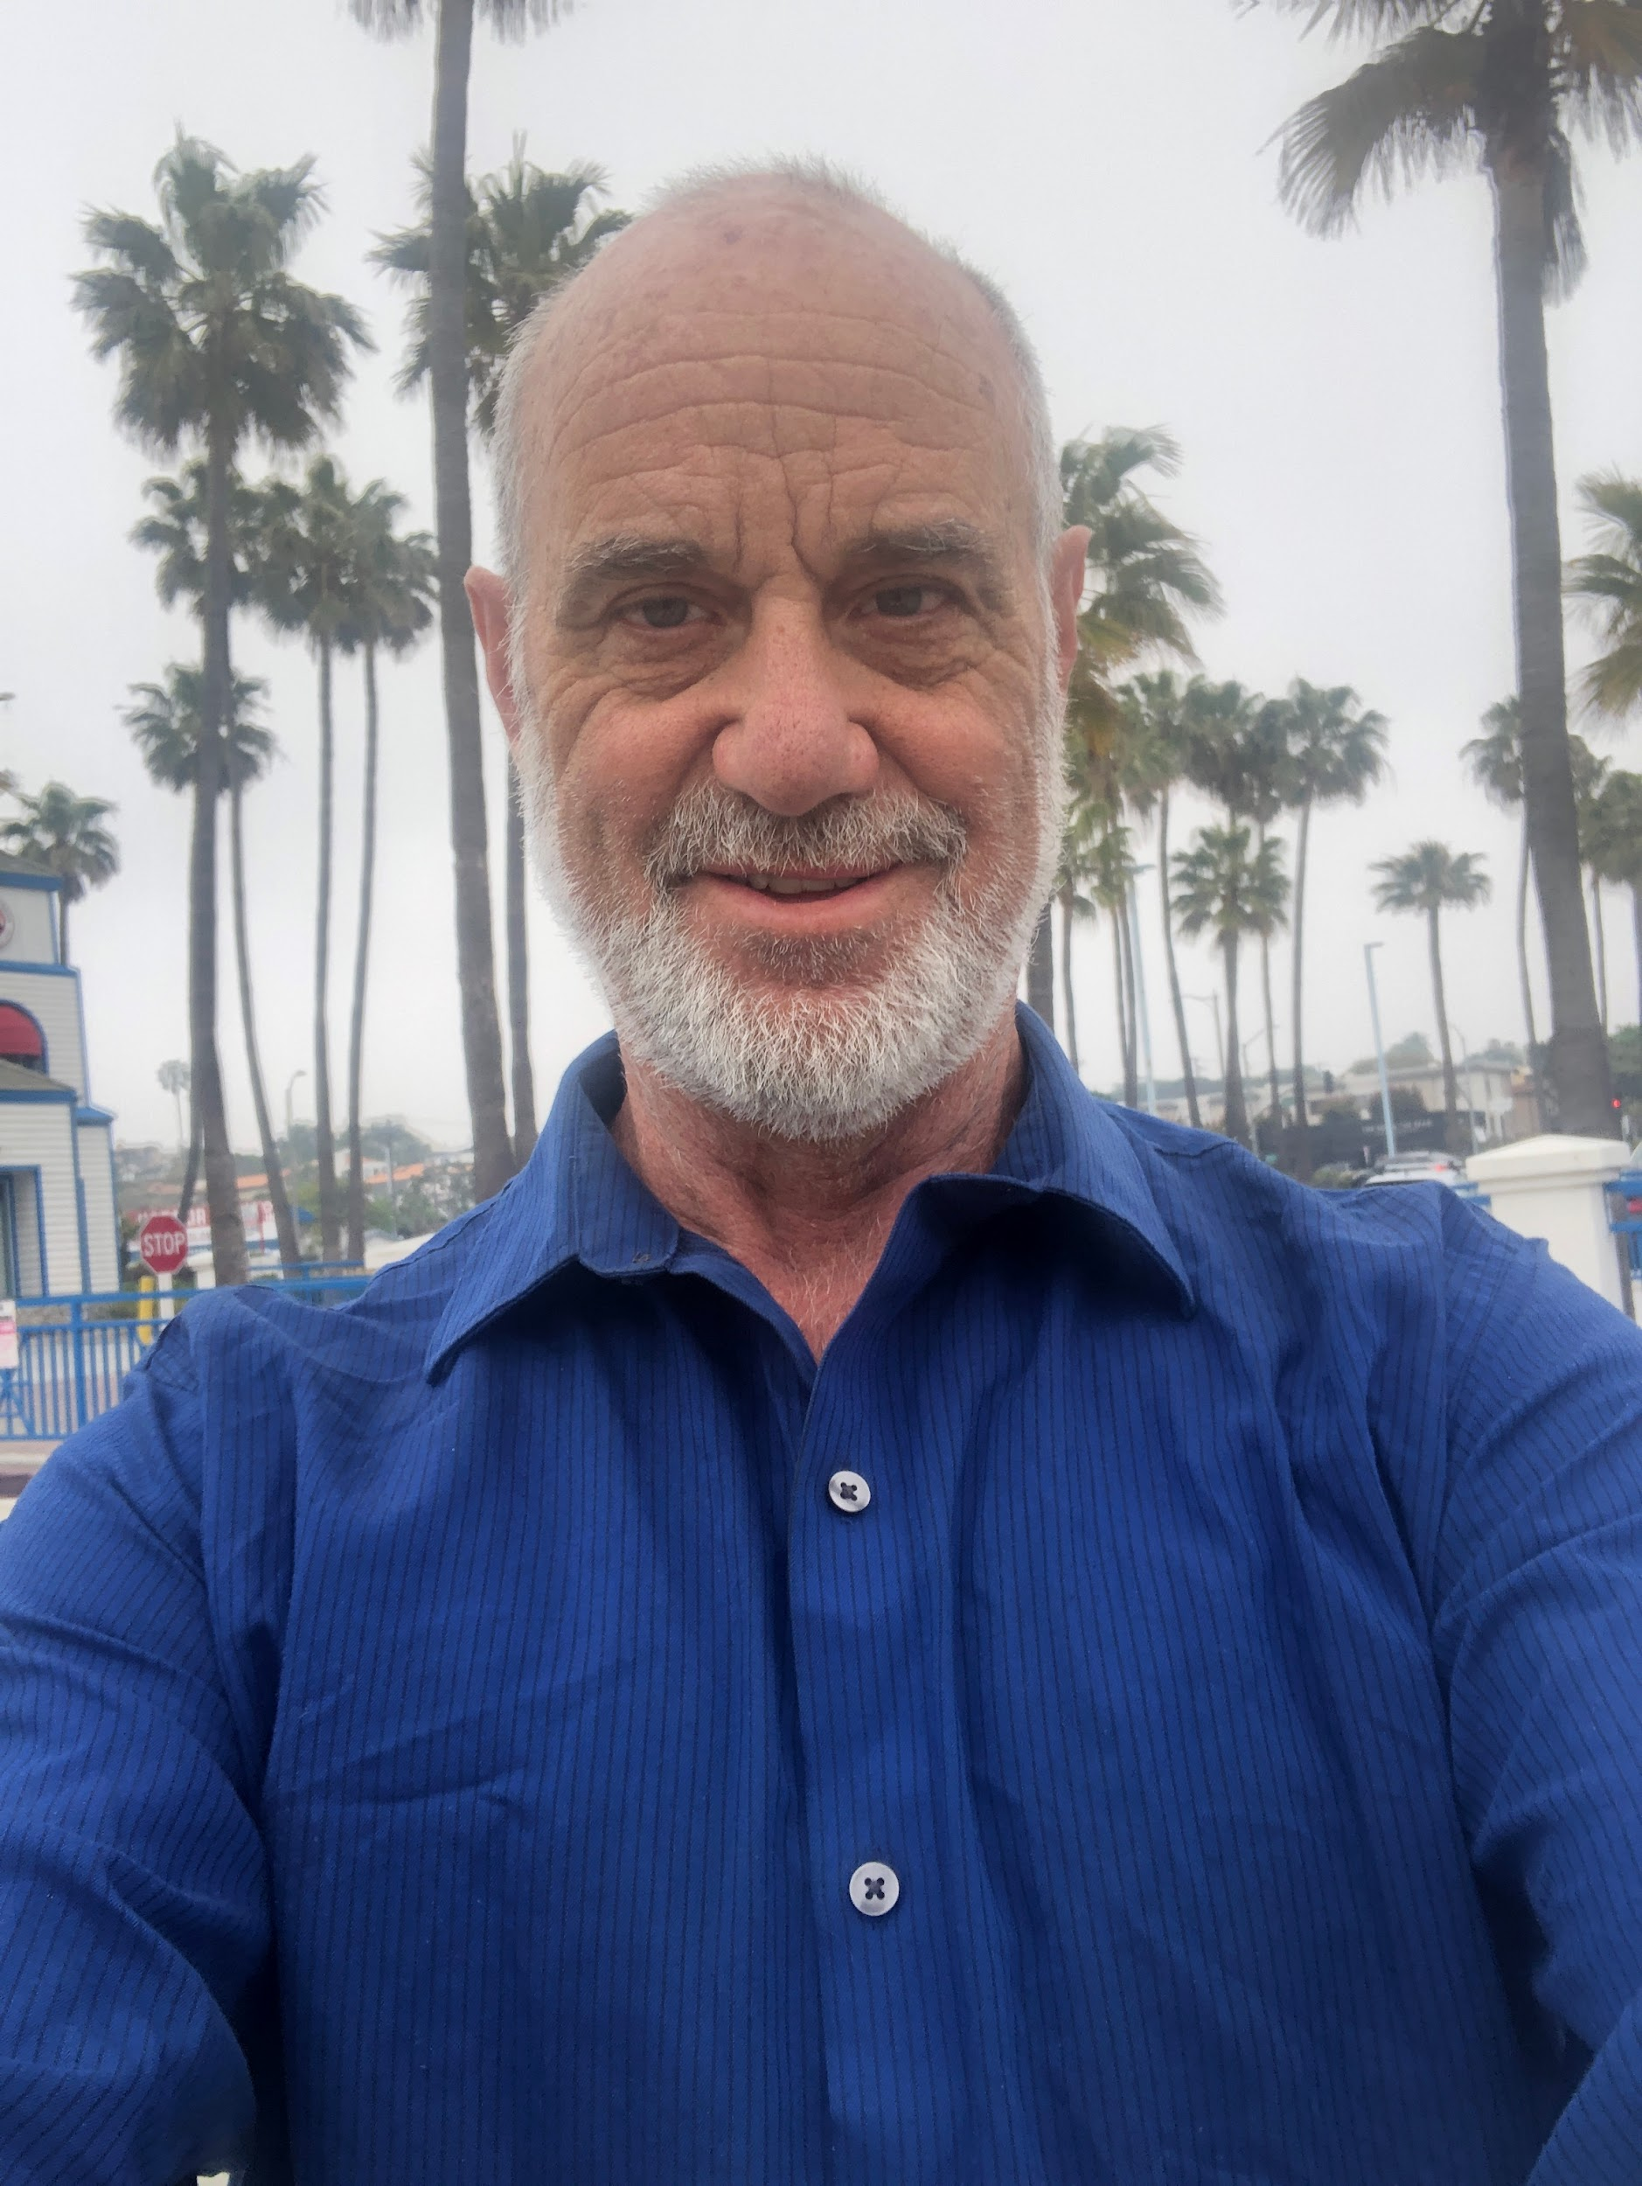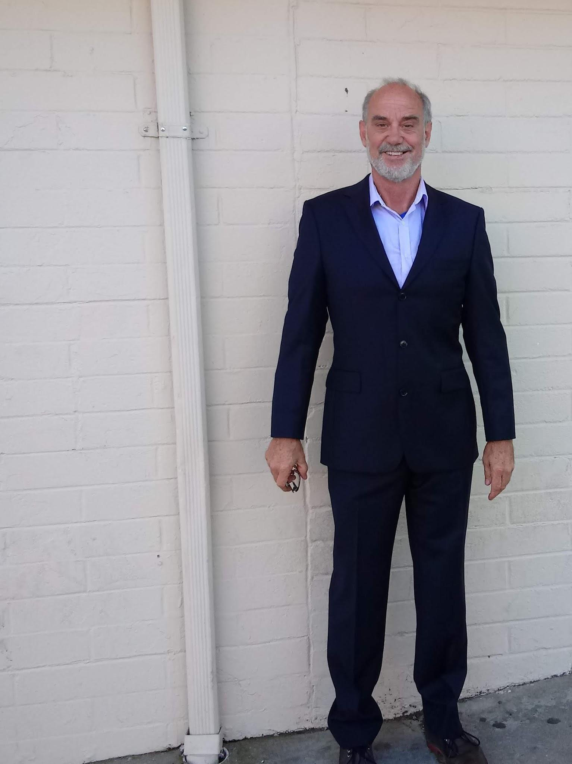

**Tom Butler**

310-663-7656

tombutler47@gmail.com

Wild models talent agency

Businessman, environmentalist, Philanthropist etc. with many skills!

Sales, acting, writing, producing, videography etc. with over 25 years of experience!

Singer/songwriter with comedic talent!

Location: Santa Monica, Ca.

Environmentalist, animal rights activist helping fight climate change

with renewable energy for homeowners in the exploding solar industry.

My **skills are that of a trainer who helps people, along with businesses, grow with exposure on Social Media, music videos, YouTube videos, commercials, etc.**

**EXPERIENCE- Have Produced and performed in over 100 videos consisting of:**

* **TV Commercials**
* **Promotional videos**
* **Music videos**
* **Documentaries, etc**

**Have hired, motivated and trained over 100 salespeople to be winners with a positive mental attitude!**

**The following is my past work experience.**

**American Display Inc. Regional Manager - We sold Outdoor Electric Signs to Independent business owners in 11 States.**

**US Payphone - Owner**

**Emcee for three years, all male dance review.**

**Written and produced Jingles, Songs, and Scripts for promotional purposes.**

**-Intermountain Energy - Sold oil and gas leases by telephone to investors throughout the USA.**

**Publisher/Editor of 5 Racing Magazines, 4 available in the local stores throughout Utah. Handled advertising, reporting, writing, motivating, etc.**

**2005 - 2008 American Residential lending- Loan Officer-**

**Handyman services, and sales in the Solar industry**

**Achievements:**

**Many awards for Achievements in Sales and communication**

**Placed in the top five in many karaoke contests.**

**Videos**

**Hurt so good** [**https://youtu.be/hDtJncUCkSw**](https://youtu.be/hDtJncUCkSw)

**Facebook shut me down** [**https://youtu.be/cORwEQNE2u4**](https://youtu.be/cORwEQNE2u4)

**“Hate arguments, try this,” A trait, most can benefit from.** [**https://youtu.be/XsJzniBsj7k**](https://youtu.be/XsJzniBsj7k)

**AT&T & Cricket commercials** [**https://youtu.be/B2f5abAQ_qI**](https://youtu.be/B2f5abAQ_qI)

**Sudden justice short** [**https://youtu.be/rPfS-BQyx8Y**](https://youtu.be/rPfS-BQyx8Y)

**Talk dirty to me** [**https://youtu.be/Pcsgu-Q0ptM**](https://youtu.be/Pcsgu-Q0ptM)

[short of she's a hot vegan](https://www.youtube.com/watch?v=QJ9JqYWrJbE)

**She bangs by Tom** [**https://youtu.be/W_EW1B7UkOo**](https://youtu.be/W_EW1B7UkOo)

**EDUCATION**

**Layton High School**

Played Sports, Snow & Water Skiing, Football, Basketball, Baseball, Golf, etc.

**Salt Lake Community College, S. L. Community College — Refrigeration & A/C.**

**SKILLS - Excellent improvisational and comedic skills**

**LANGUAGE**

English only

Looking forward to helping and working with you.

**E-Mail- tombutler47@gmail**[**.com**](mailto:tombutlerandassociates@gmail.com)