**Mei-Jen (Jennifer) Hong Hillary**

2003 pin oak pkwy, Bowie, MD, 20721

[meijenhong@yahoo.com.tw](mailto:meijenhong@yahoo.com.tw) Telephone #: 443-605-7303

**My goal/objective for employment:**

I hope to become an advocator, a supporter, and a healer for the patients. Mental health is a seed in our brain, and it must be planted right time and right moment. As time goes by, people who planted earlier will cultivate throughout their lifetime. People who do not prepare any seed (social interpersonal connection, support, health physical activities, balanced nutrition, financial independent, and quality sleep) in life, they may suffer from physical illness, mental distress, and memory loss in early lifetime. My goal is to promote our mental health and physical hygiene of human being.

**Certifications & licenses:**

1.RN - License number=R201743 2.CNA – June 2010

3.Certified phlebotomy technician (2009) 4.CPR/BLS – 05/19/2023-05/19/2025

5.ACLS certificate: 07/20/2023-07/20/2025

6. PMHNP: NPI number: 1669156097.

7. ANCC certificate: #2023003416 (4/29/2023 to 4/28/2028)

8. Maryland Board of Nursing for PMHNP: R201743

9. CDs (controlled dangerous substances) =N117559

10. DEA License (Drug Enforcement Administration): 08/31/2023-10/31/2026

**Education**

1. Walden University Psychiatric Mental Health nurse practitioner program- (graduate in August 2022).
2. UMUC BSN program (2015 spring. –graduate in May 2017).
3. Anne Arundel Community College (Associate of Science degree in Nursing – May 2012).
4. National Chung Hsing University (B.A., (Economics)– Taipei, Taiwan – May 1993).
5. Mini-MBA— (1998 -1999) for Industry management and budget analysis.
6. Taipei First Girl High School (graduate in 1988).

**Professional experience:**

**PMHNP Certificate: #2023003416 (Valid 04/29/2023-04/28/2028)**

**PMHNP student**

1. **Professor Leighton Kennedy, PMHNP (Summer 2021, Spring 2022):**

Innovo Life, LLC. Address: 8101 Sandy Spring Rd. Suite 250. Laurel, MD 20707.

Tel: (240) 755-8675

1. **Dr. Bergina Isbell. Psychiatrist (Winter 2021, Summer 2022):**

Ledlife. LLC. Address: 3355 Saint Johns Ln Ste F Ellicott City, MD 21042.

Tel: (240) 644-4937

1. **I currently work for Dr. Bergina Isbell, and she has accepted me as her staff member. I work for the doctor’s office for CPT, CBT, Motivational treatment, Spravato and Ketamine in office treatment and processing. I have been working with Dr. Isbell’s office since September 2022 until today 10/6/2023. The weekly working hours are 15-20 hours.**

**The patients’ age groups are from 7-77 years old.**

**Tasks:**

1.Totally providing 500-600 patients’ (geriatric, adolescent, adults, and children) mental cares, assessment, diagnosis, interventions, medication prescriptions, and treatment plans in clinical settings during 4 semesters in a year.

2. Spravato inhaler treatments in the clinical setting with Dr. Isbell.

3. Medication prescriptions to 500 patients instructed and independently prescribed under the supervision of both preceptors. The medications’ (mood stabilizer, SSRIs, SNRIs, Stimulant, antipsychotics, lithium, Benzodiazepines) effectiveness and side effectiveness are educated to the patients.

4. Providing wholistic intervention, care plans, and treatment options to the patients.

5. 500-600 patients with various mental disease and personality disorders (ADHD, PTSD, MDD, GAD, OCD, TRD, Suicidal thoughts, action, and ideation, Schizoaffective disorder, Schizophrenia, Psychosis. Alcohol withdrawal encephalopathy, adjustment disorder, Insomnia…)

6. Assess advanced practice psychiatric-mental health nursing skills (nursing physical, initiating the required restraints, the updated CPR certificate, the updated ACLS certificate, administering the suicidal patients’ monitor and supervision, team support, and pathophysiology) for strengths and opportunities  
7. Develop professional treatment plans (pharmacologist, non-pharmacologist, CBT, humanity support, group support) in advanced nursing practice for the practicum experience  
8. Apply advanced practice nursing assessment, diagnosis, and treatment skills in mental health settings. I have crisis intervention abilities, communication skills, listening skills, and direct supervision abilities.  
9. Analyze cases involving advanced care of patients across the lifespan in mental health settings (I help the patients with their HTN crisis arising from their excessive worries, sending the patients to urgent care, I have De-escalation techniques, and I can assist the patients to deal with the conflict resolution).  
10. Formulate differential diagnoses (various presentations for different patients with different mental disorders during my school semesters) for patients across the lifespan (children, adolescents, adults, and elderly) in mental health settings  
11. Formulate appropriate treatment plans that include psychopharmacology and psychotherapeutic techniques

**Nursing-Related Experience**

1.University of Maryland Baltimore Washington Medical Center, Registered Nurse

301 Hospital Dr. Glen Burnie, MD. 21061 (2018-Now/2021)

Telemetry Medical surgical unit- 7 west, Tel: 410-787-4000 (Floor Manger Ms. Heys.)

**Tasks:**

Chest tube management**,** colon ostomy care, Urinary catheterization, TPN, IV, PICC line therapy, Peripheral line insertion, wound dressing care, Telemetry Monitor, EKG stripes, NPWT machine operation and wound dressing care, pressure ulcer care, burn skin care, tracheostomy suction and care, Insulin injection, G tube/PEG feeding tube care, Nebulizer care, CPAP care, stoma care, code blue experience, Craniotomy care, post-mastectomy care, laminectomy care, medication administrations, psychological comfort and delegation jobs to GNAs, CPR

2.University of Maryland Regional Hospital, Registered Nurse

3001 Hospital Dr. Cheverly, MD 20785 (5/2017-4/2018)

Telemetry Medical Surgical uint-E700, Tel: 301-618-2700 (Ms. Glenda Akinbinu)

Tasks:

Colon ostomy care, Urinary catheterization, TPN, IV, PICC line therapy, Peripheral line insertion, wound dressing care, Telemetry Monitor, EKG stripes, NPWT machine operation and wound dressing care, pressure ulcer care, burn skin care, tracheostomy suction and care, Insulin injection, G tube/PEG feeding tube care, Nebulizer care, CPAP care, stoma care, Craniotomy care, post-mastectomy care, laminectomy care, medication administrations, psychological comfort and delegation jobs to GNAs, Full code CPR

3.Genesis Health Care Management Cooperation, Registered Nurse

1221 Waugh Chapel Road. Gambrills. MD. 21045

July 2015 – 2018)—part time weekend and every Wednesday

Tel: 410-923-2020 (Ms. Tanya Barnett. Jocelyn Surino =DON)

**Tasks:**

Colon ostomy care, Urinary catheterization, TPN, IV, PICC line therapy, Peripheral line insertion, wound dressing care, NPWT machine operation and wound dressing care, pressure ulcer care, burn skin care, tracheostomy suction and care, Insulin injection, G tube/PEG feeding tube care, Nebulizer care, CPAP care, stoma care, Craniotomy care, post-mastectomy care, laminectomy care, medication administrations, psychological comfort and delegation jobs to GNAs, Full code CPR

**Teamwork:**

* We must assist the team members while we perform the nursing assessments.
* To manage and arrange the assignment for RNs and GNAs.
* Delegation the tasks to GNAs. Referral the further treatments to adequate departments (social worker, PT, OT, psychological, dietitian consults etc.).
* Nurse Manager at times: 7 nurses, 9 GNAs assignments in the Genesis Health Care Cooperation
* Provide the collaborated teamwork to provide the utmost satisfaction for the patients.

4. Future care Health and Management Corporation, Registered Nurse

305 college parkway, Arnold, MD. 21012.

June 2014- April 2015

Tel: 240-687-2420 (Ms. Kady =Nurse Manager, kady914@gmail.com)

**Tasks:**

Colon ostomy care, Urinary catheterization, TPN, IV, PICC line therapy, Peripheral line insertion, wound dressing care, negative pressure wound therapy, pressure ulcer care, tracheostomy (suction and trach cannula sterile care), Insulin injection, G tube/PEG tube feeding care, laminectomy care, Nebulizer care, stoma care, medication administrations, Full code CPR.

**Teamwork:**

The importance management of patients’ care to provide the patient-centered care and delegation the tasks to GNA are important teamwork in this facility**.**

5. Rainbow Senior Day Care Center, Nurse Manager

9135 Guilford Rd, Columbia, MD, US, 21046

July 2012 – 2015. Manager/ Mr. Jeff Wright=410-303-3670

**Tasks:**

1. Assess and intervene the abnormal signs and symptoms of disease process.

2. Medication administration.

3. Translator for medical issues between Chinese and English.

4. Provide average 120 patients’ care and documentation the incident reports.

5. Education projects for individual patient, personalized care plan.

6. Provide colon ostomy care, tracheostomy care, G tube feeing, insulin injections,

Heparin injections, wound care, burning, insects’ bites, stoma care, medication

education, pharmacy contact and communicate with physicians.

7. Contact Maryland Mental and Hygiene Department for admission new patients.

8. Referral patients to adequate services (social worker, PT, OT, psychological, dietitian

consults etc.)

9. Provide the patient-centered care and qualitative care to the seniors, collaborate with the

administrative department, promote the facility to the well-reputation adult day care center

among other facilities.

**Honors/Awards (as applicable):** Not applicable.

**Checklist for Portfolio (1. Personal philosophy statement)**

As a mental health provider with a Chinese cultural background, I have noticed that many patients are physical ill, and extreme mentally ill during the pandemic. The physical ill can be fixed with fluid, surgeries, and medications. However, mental, and spiritual dysfunction need time, effort, and support. Sometimes, it takes months and years to heal the individual’s trauma experience, depression, and obsessive compulsion disorder. Sometimes, it never heals.

My philosophy about mental health is deeply influenced by the Taoism which was developed by Tao Tzu who wrote the “Tao Te Ching” book around 500 B.C.E. His “Tao Te Ching” suggested the human, animal and living objects to live in balance with the Tao and universe. If you wake up in the morning, and there are two choices for you to choose: Happy or Sad? Which one will you choose? The answer is very easy: “Happy”. However, many people choose “Sad” “Unhappy” from the sunrise in the modern times. People create barriers, unlimited desire, frustration, unrealistic dreams to achieve, and more great walls in their lives. Once people cannot reach their goals, they become deeply humiliated with themselves, throw anger to their families, and depression develops.

Our universe should be balanced with Ying and Yang, which we should live in a balanced environment of chi, or energy. Hence, we will not build anxiety, greedy, or too much desire that we cannot reach. When things are not planed as we wish, we start to be irritable, impulsive, panic, and confused. People lose control of the great circulatory cycle and the small circle of the evolutive. To perform Daoism/Taoism is mindful, resilience, and meaningful. We are not separatable with the natural. In fact, we should respect nature, learn from the nature, and listen to the nature’s cycle.

We should plant the seeds (the good balanced diet, nutrition, philosophy, social connections, happiness, mutual support, interpersonal relationships, hopes) to our communities and our societies. We will cultivate in the future. If we try to hurt, injury, and take away these seeds; one day we will suffer. We will be in desperate condition. Eventually, we become mentally confused, unhappy, physically ill and psychosis.

We should set good examples for our next generations, establish rules and boundaries, let the families know the consequence of using substances. We should teach our communities to leave substances, and our population health can rise from the ashes.

**Checklist for Portfolio (2. Personal goals: short term and long term)**

**Short term goal:**

I hope I can provide my qualitive and quantitative care for my patients in the community and state (Maryland, California, New Jersey) level in two years. California and New Jersey states have the most Chinese population. Maryland is my home state. My goal is to provide adequate mental health consultation to the patients in these three states.

Provide better care and services to the mental distress patients in Maryland. My passionate, diligent, and supportive care will make the difference to the community and decrease the stigma of mental disorders.

**Long term goal:**

I hope to establish a campaign or alliance to ask the government and senators to increase our mental health care funding to our mental health population. I hope to create more community health centers for mental distress patients to come to volunteer, learn, and earn living skills. After they learn living skills (cooking, baking, cleaning, technician, painting, etc.), they become more independent. Once their financial abilities increase, they frustration can decrease. The mental distress, anxiety and depression disorder can decrease.

**Checklist for Portfolio (3. Self-assessment)**

**Self-assessment:**

1. I follow my goals, plans, and stick on my schedules. Therefore, I complete 100 % of my schedules. I keep my words, and I accomplish them. I do not call out unless it is the medical issues. I never late for work for 12 years since I start work in America. I overcome the expectations the job needs me to do. My managers agree with it.
2. I enjoy reading and growing garden, each year I pay attention to the water, nutrition, and sunshine to my plants and vegetables. We need to have patience, mindful cares, cutting the weeds, and add the necessary electrolytes when we nurture the plants. I do believe adequate support, nurture, assistance will make people success. We can become better ourselves if we have professionals, experts, and caregivers assist us. An Olympic winner still needs a coach, nutritionist, and sport medicine to help him. We are only the ordinary people; we need more support in the universe. Therefore, I will continue to ask for assistance if something I do not know.
3. I am not a stubborn person, but I am tenacious as one of my professors tells me. If I insist to complete one task, I will use my extra energy, time, and effort to achieve it. I will keep trying with different methods and I will not easily give up. I enjoy mental health courses and I devote my time to do extra research if I do not get the information I need. Therefore, my suspicious questions, or my doubt can be resolved.
4. I do charity, and I help the families who lost children, wife, husband, parents in the earthquake. I am a humanity person. I believe in Taoism, the energy will circle around, and we should put our good energy to the universe. To help one person, we may help whole families, and may save whole communities. We should continue to help the society that helps us to grow.

**Other**

**Languages** –

* Native speaker of Mandarin and Fukienese (Taiwanese),
* Fair reading and speaking knowledge of Spanish and Japanese.
* Excellent spoken and written English abilities.

**Computer skills** **–**

* Experienced in researching medical issues using the National Library of Medicine databases;
* Experienced in the use of Microsoft Word, Excel, and PowerPoint.

**Pictures of Mei-Jen Hong Hillary.**

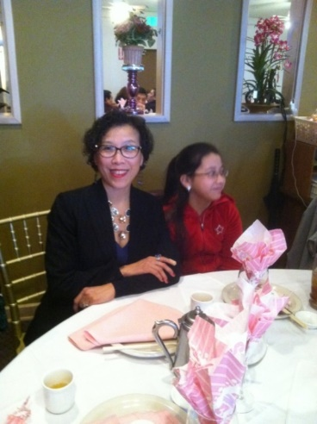 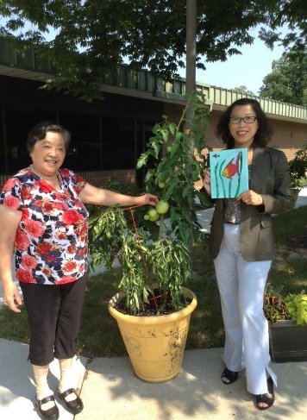 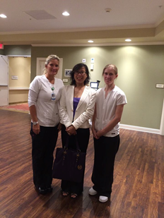

**Threee references letters:**

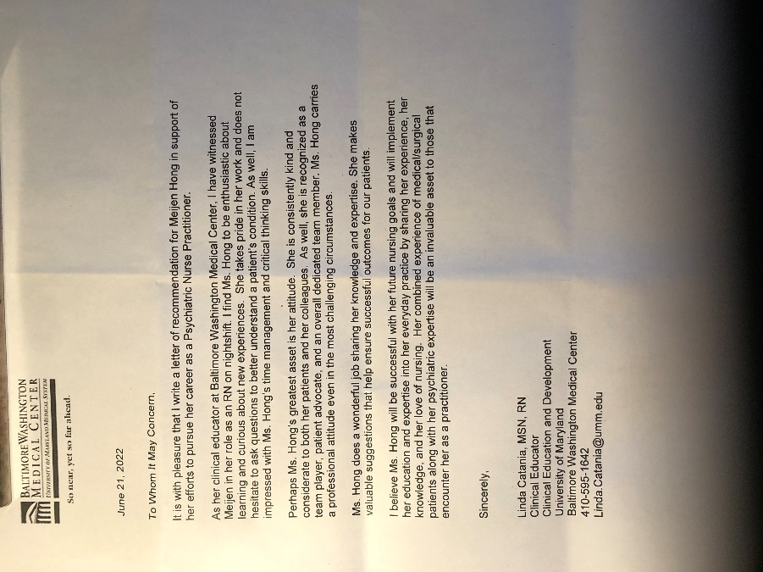 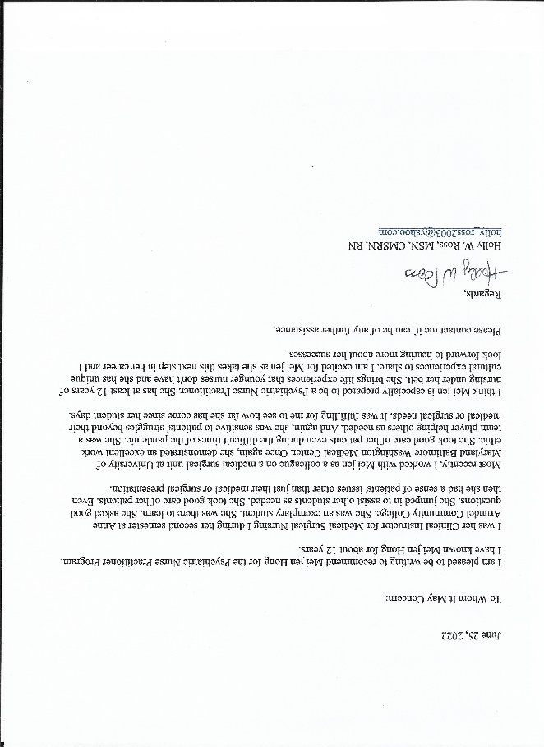

To whom it may concern,

This is a recommendation letter for Mei-Jen Hong Hillary, BSN, RN.

Mei-Jen joined my team on 7 West at University of Maryland Baltimore Washington Medical Center on July 8, 2020 after spending 2 years on a sister unit. 7 West is a Medical Surgical unit with a wide array of diagnosis’s. Often mental health is part of the medical condition of the patients we care for. Mei-Jen not only brought her expertise but her compassion for caring. She is the Zen our unit and is very thoughtful to her patients and her colleagues and often bring little gifts or items from her garden. Mei-Jen establishes caring relationships with her patients to promote a healing environment.

When Mei-Jen told me that she was enrolled in her advance degree program with a specialty in mental health, I thought she is the perfect person for this profession. She recognizes the opportunity to inspire in people’s wellbeing and hopes to have a positive impact on their outcomes. Metaphorically like growing her garden and the nurturing it takes to make it successful. Mei-Jen believes with nurturing and the learning she is obtaining for her Nurse Practitioner Program, she can have a positive impact on mental health.

Currently as a Nurse on my unit Mei-Jen has a strong work ethic. She maintains a good attendance record with minimal unscheduled leaves and zero lateness. She completes her work on time, she is thorough and her patients are happy. Mei-Jen has opportunities to pick up additional shifts and has done so to help her family members in need.

I see a bright future for Mei-Jen in the world of mental health. Mental health really is a basic need and touches just about all the patients on my unit. I look forward to seeing her in the Advanced Practice role helping others.

Deborah Heys, MSN, RN-BC

Nurse Manager 7 West

410-787-4000