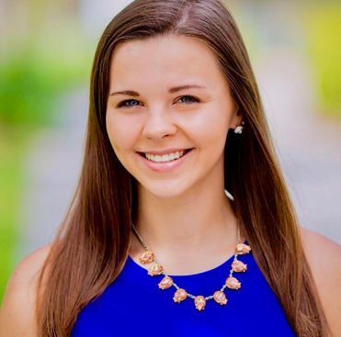
Taylor Zajdowicz
2207 SW 39th St.
Cape Coral, FL 33914
(716)-545-2922
taylorlynnez@aol.com

EDUCATION:
Past: Present:
High School Diploma Bachelor’s Degree in Health Science
Ida S. Baker High School Florida Gulf Coast University
August 2014- May 2018 August 2018- May 2022

WORK EXPERIENCE:
Emergency Medicine Scribe for Scribe America
August 2019- Current Employer Full Time Employee
- Obtain history from patients to create the HPI and identify their Chief Complaint
- Complete ED encounter note using EPIC EMR Software
- Answer ED physician phone to relay messages of critical imaging or lab results
- Work with physician to obtain physical examination and differential diagnoses

Front Office Assistant for the Office of Undergraduate Studies at Florida Gulf Coast University
August 2018 - August 2019 Part Time Employee

- Created and organized files of QEP courses
- Completed Excel spreadsheets of data regarding degree programs
- Assist students with signing in for appointments using an iPad
- Created flyers using Canva for various office events

Marketing Assistant for Stun City Florida
December 2016 - October 2017 Part Time Employee

- Visited local businesses to market stun guns product
- Assisted with financial aspects of SCF
- Participated in video shoots with the product
- Managed a stand at various Florida Gun Shows

SPECIAL CERTIFICATIONS:
- Microsoft Word/Powerpoint/Excel - 2015
- BLS/ CPR and AED Certified - 2017
- Certified Electrocardiogram Technician - 2018
- Certified Phlebotomy Technician – 2018
- EPIC EMR Software - 2019

