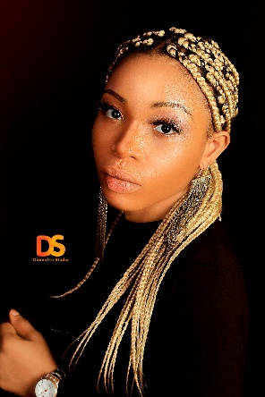

**ABIGAIL OGOZI**

Nationality: Nigeria

Email: ogoziabigail@gmail.com

Phone: **07344070075**

**08062902235**

**ABOUT ME**

Multi-tasking Consultant well-known for successfully taking projects from beginning stages to completion. Polished and professional offering proficiency in Type technology. Commended for consistently meeting new technical challenges and finding solutions to satisfy customer needs.

Talented Consultant with excellent client oversight, issue resolution and presentation skills. Highly effective at juggling multiple tasks and projects.

Operations Specialist with experience developing realistic solutions to assure satisfactory consumer and customer experiences. Fluency in Language. Committed to resolving problems and maintaining accurate metrics and reports.

Team Leader experienced in directing activities in Type setting. Talented at developing strategies, setting goals and training employees. Confident and decisive when communicating goals and vision to succeed. First-class problem solver with excellent interpersonal skills.

**CAREER OBJECTIVES**

To play an active role in challenging job environment with the necessary condition of service. Vision focused, result oriented to meet the fulfillment of the overall goals and objectives of the organization.

**PERSONAL DATA**

SEX FEMALE

DATE OF BIRTH April 7th ,1996

RELIGION CHRISTIAN

MARITAL STATUS SINGLE

STATE OF ORIGIN CROSS RIVER

L.G.A ABI

NATIONALITY NIGERIA

**PERSONAL SKILLS**

* Excellent communication skills
* Ability to work in a challenging environment
* Target oriented
* Ability to work in a team

**QUALIFICATIONS**

* Heritage polytechnic: 2018

HND in Mass communication

* Kaines computer:

Executive diploma in computer training 2015

* Senior School Certificate Examination 2012

(SSCE) NECO:

El-Shaddai model academy

* Primary School Leaving Certificate: 2006

Learning field academy

**WORK EXPERIENCE**

* Class teacher 2020
* Medical sales representative

Osworth Nigeria limited, uyo 2018

* Consultant@

Adultchess consultancy 2019

* Editor@

Cronicle Newspaper 2017