**Christina M. Bentley**

♦

1018 Cassabella Cove

Memphis, TN 38018-1405

901-754-5102 cmbentley3@gmail.com

To Whom It May Concern;

This letter is in response to your opening for a Manager; I am presenting myself as the candidate who possesses the experience, skills, and qualities you are searching for.

Through my strong educational background and 12 years of experience as a paralegal, I have developed expertise in Coordinating the following areas of law: contracts, agreements, compliance, litigation, complaints, interrogatories, motions, orders, production requests, admission requests, and deposition notices, among many other disciplines.

I also have several years of experience in Sales, Product Management, and Information Technology, through my work as a Manager at Kirkland’s Department store first as a sales associate, then as a Manager, and then with my work in several hotels in the Memphis and surrounding areas. Regardless, of what your position is in the Hotel Industry, Sales, Product Management (banquet and reception halls availability and upcoming events), and Information Technology is a mandatory part of your job description.

I have developed my organizational, accounting, administrative, litigation, project coordination, and project management experience through my endeavors and studies in a wide range of cases and fields. I also possess an extensive background in financial management. I am currently pursuing a Master’s Degree in Information Technology Management with a Master’s Certificate in Project Management.

I possess and can demonstrate all the following you are looking for:

- Organization Skills - Professionalism - Integrity

- Strong Work Ethic - High Energy - Multitasking

- Follow up - Dedication - Research

- Communication Skills - Analytical Skills - Computer Skills

- Strategic Thinking - Strategic Management - Strategic Planning

- Quality Principals - Quality Management - Servant Leadership

I look forward to hearing from you.

Sincerely,

Christina M. Bentley

901-754-5102

**Christina M. Bentley**

♦

1018 Cassabella Cove

Cordova, TN 38018-1405

901-754-5102 cmbentley3@gmail.com

**Project Manager**

I present a professional paralegal with 12 years of experience, and project manager with10 years of experience and a proven record of accomplishment in project management, information technology management, legal research, quality control, litigation, customer service, and a strong financial background.

**My Skill Sets Include:**

• Litigation (Coordination) • Compliance • Document Review • Document Preparation

• Legal Research • LEXIS / NEXIS Searches • Complaint and Answer • Interrogatories /Motions

• Production Requests • Admission Requests • Deposition Notices • Oracle / SAP

• Orders • Briefings • Case Status Reports • Payoff Information

• Title & Closing Management • File Maintenance • Case Calendars • Project Management

• Resource Management • Due Diligence • Office Management • Project & Program Coordination

• Investigations • Negotiations • Payroll Issues • Financial Planning Research

• Contracts/ Agreements • Audits • Tax Code & Returns • Customer Service Manager

• Employee Training • Balancing Accounts • Entrepreneurship • Quality Assurance Management

• Stakeholder Engagement • Risk Management • Conflict Management • Cost Management

• Scope Management • Planning • Integration Management • Monitoring & Control

• Schedule Management • Communications •Procurement Management •Initiating Management

• Executing • Microsoft Office & Projects • Change Management • Lessons Learned Management

**Professional Progression**

**Cigna (Accredo) Eligibility Representative 06/2021 - Present**

Delivers straightforward administrative and/or other basic business services in Eligibility. Implements and maintains eligibility for benefits.  Implements, updates, and maintains automated, direct connect and/or manual eligibility data. Interacts with internal partners and/or external clients/vendors. Generates reports to identify and resolve discrepancies.  Identifies process improvement opportunities for own cases.  May negotiate and resolve eligibility with clients. May provide technical support for the electronic processing of eligibility. Ensures customer data is installed accurately and timely.  May work with client's format and internal Systems to resolve errors. May interact with Systems to resolve technical issues. General knowledge of manual and automated eligibility. Familiar with reporting tools.  Technical understanding of systems.  Issues tend to be routine in nature. Good knowledge and understanding of Eligibility and business/operating processes and procedures. Works to clearly defined procedures under close supervision.

**ESSENTIAL FUNCTIONS**

* Facilitates cross-functional resolution of drug coverage issues & proactively address, researches & resolves issues impacting revenue optimization.
* Performs medical /pharmacy benefits verification requiring complex decision skills based on payer and process knowledge resulting in onboarding or no starting specialty patients.
* Contacts benefit providers to gather policy benefits/limitations.
* Coordinating and ensuring the services provided will be reimbursable (e.g., deductible amounts, co-payments, effective date, levels of care, authorization, etc.).
* Directly interfaces with external clients.
* Provide expert assistance to clients on patient status.
* Liaison for the company providing referral status reporting.
* Handle Escalations.
* Use discretion & independent judgment in handling pt or more complex client complaints, escalating as appropriate.
* Completes other projects and additional duties as assigned

**FedEx Trade Network (Tyndale)** **ECO Import Coordinator-(CPA)** **11/2018 -01/2020**

This position is responsible for any of the various tasks listed as assigned. Decision making for release related tasks, assigning work to the appropriate queue for proper entry processing, live/quota entries, FDA/FWS entries, scrolling, voids/deletes and voluntary entries utilizing computer skills in a windows environment. Maintains uniform business practices and procedures to ensure compliance with customs and OGA laws and regulations and according to FedEx express expectations. Analyzes documentation provided to determine that harmonized tariff number and whether the shipment qualifies for special tariff treatment, NAFTA, reduced duty rates and ensures all government agency regulations are followed. Also ensures that the required information is submitted or transmitted electronically. Completes the classification of imported merchandise by determining the proper tariff classification and associate duty rate, and calculating the entered value using t/b and FedEx systems. Contact customers to resolve classifications questions or to obtain government documentation required for entry. Completes the release and classification processing of each aged shipment after obtaining all missing information or documentation or move to the proper queue for processing. Answers inquiries by FedEx express and FedEx express customers about the clearance status of any shipment. Accesses the internet, FedEx systems for customer databases, spreadsheets & manifest scrolling. Communicates with customers, CBP and other government agencies in order to obtain information necessary for release. Analyzes and researches unapplied cash and non-payments by using accounting systems (ODQ) and mainframe application 74. Makes necessary adjustments to the FedEx account as requested by management. Processes all monthly and additional invoices that need to be sent out to FedEx express. CCP • Certified Customs Professional and *QDM* (Quality Driven Management) certified.

**Hilton Garden Inn (Cordova) Night Auditor/ *Front Office Supervisor* 2/2016 –11/2018**

Provided excellent customer services and assisted customers throughout their stay. Balanced the Food and Beverage account (Gift Shop, Restaurant, Bar, and Room Service) daily and close and opened hotel for the next business day. Verified that room and tax were posted, posted Banquets and Audio-Visual accounts to the general ledger, and corrected any erroneously posted transactions. *CRM* (Customer Relationship Manager) certified.

**Hampton Inn & Suites *G.S.R./ Front Office Supervisor* 7/2015 – 2/2016**

Assisted the guests with their check-in and check-out process, assigned work schedules for housekeeping, engineering, and front desk staff, and trained new front desk employees. CRM (Customer Relationship Manager) certified.

**World Ventures (Travel Agency) *Entrepreneur* 5/2012 – 5/2014**

Currently coordinate and plan national and international travel ventures for clients’ personal and business use. Responsible for the training and directing of new employees, organizing, and directing of client meetings and preparing audio/visual needs and refreshments as necessary. Host and teach potential clientele about traveling benefits, resolve issues and disseminate travel information via E-mail and text messages. Home based business.

**Counsel on Call *Project Manager (Local Offices)* 9/2006 – 7/2015**

***Contract Paralegal (FedEx)******12/2006 – 3/2008***

*Various hours per contract*

Currently perform various duties as a paralegal as dictated by the contract; Various days, and hours and locations;Assist in resolving problems and distributing general information via Email correspondence; Perform administrative duties, scheduling and coordination of meetings and helping manage and develop the company’s new office. Prepared the International Alcohol Reports in spreadsheet format to eight reporting states within the US, with supporting documentation for the Alcohol Beverage Commission for twelve US states. RP • Registered Paralegal (May, 2007), MOUS • Microsoft Applications (August, 2008), and NP • Notary Public (June, 2013).

**Holiday Inn (University of Memphis)** ***F.E.C. Part Time-Night Auditor* 2/2005 – 12/2008**

Provided exceptional customer service to all guests at the Fogelman Executive Center (F.E.C.) throughout the entire process of their stay (Opera). Balanced the banquet accounts daily, prepared the hotel for open and close each day and verified that room and tax were posted. Posted Audio Visual accounts to the general ledger and corrected any erroneously posted transactions.

*Achievements:*

* Recognized with the Torch Bearer Award for exceptional guest service and guest satisfaction.

**Kirkland, Rothman-Branning & Associates *Paralegal Intern* 5/2006 – 8/2006**

Assisted with the preparation of vital closing documents, including but not limited to: gathering payoff information, assisting with the preparation of documentation for package shipment, assisting in file maintenance, research payoffs and assisting the assigned attorney in clearance of title issues, post-closing issues, litigation files and other duties as assigned. Non- paid internship.

*Achievements:* Became a Member of the Memphis Paralegal Association and Director of Communication.

**Marriot-East Hotel *Lead Night Auditor/Supervisor* 6/2003 – 2/2005**

Provided excellent customer services and assisted customers throughout their stay. Balanced the Food and Beverage account (Gift Shop, Restaurant, Bar, and Room Service) daily and close and opened hotel for the next business day. Verified that room and tax were posted, posted Banquets and Audio-Visual accounts to the general ledger, and corrected any erroneously posted transactions.

**The Grand Casinos & Resorts *Supervisor of Front Desk Operations* 4/2002 – 1/2003**

Trained, directed, and supervised associates for three hotels located on the property (front desk, PBX, and bellmen) and provided outstanding customer service to each client throughout their stay. Balanced the guest accounts according to the wishes of the casino host (Gift Shop, Restaurant, Bar, Room Service, and Sporting Fees) daily, resolved guest disputes and prepared the stop and start of the hotel for the next business day. Verified that room and tax were posted, adjusted rates, corrected any erroneously posted transactions, audited time for hourly associates and prepared weekly and daily reports for upper management.

**American Home Shield *Accounting Call Associate* 1/2002 – 4/2002**

Assisted all home warranty customers with any questions or concerns regarding their warranty account, verified information about a homeowner’s personal accounts and prepared the initial setup of warranty. Conducted account research on past and present payments and service fees, and assisted vendors with questions on presenting their bill for payment if needed.

**Adams Mark Hotel (Closed) *G.S.R./ Lead Night Auditor* 9/2000 – 1/2002**

Aided all guests at check-in, during their stay and at check out. Balanced the Food and Beverage account (Gift Shop, Restaurant, Bar, and Room Service) daily, closed and reopened the hotel for the next business day, verified that room and tax were posted, posted Banquets and Audio-Visual credit card transactions, and corrected any erroneously posted transactions.

**I.R.S. – Document Perfection *Tax Examiner (Seasonal)* 1/2000 – 5/2000**

Verified, corrected, and coded tax returns during the tax season, suspended the tax returns until the correct information could be obtained and entered restricted information into the computer system.

**Kirkland’s Department Store (Closed) *Sales Representative/Assistant Manager*** **6/1996 – 1/2000**

Assisted customers in their choice of merchandise, prepared payroll, hired and trained new employees and terminated employees when warranted.

**Extended Stay America *G.S.R./ Front Office Manager* 8/1998 – 3/1999**

Assisted the guests with their check-in and check-out process, assigned work schedules for Housekeeping, Engineering, and Desk staff, and trained regional front desk employees.

**Education & Certification**

Webster University, MILLINGTON, TN (Anticipated Graduation May, 2019)

Master of Arts in Information Technology Management with a

Master’s Certificate in Project Management with a **G. P. A. 3.50**

Union University, GERMANTOWN, TN (MAY, 2017)

Bachelor of Science in Organizational Management: Project Management with a **G. P. A. 3.7**

Southwestern Tennessee Community College, Memphis, TN (May, 2007)

Associate Degree of Applied Science: Business Administration and Paralegal Studies,

Concentration in: Real Estate, Corporate and Banking

State of Tennessee Certified Notary Public (Through May, 2021)

Insured and Bonded

**Computer Skills**

•Windows (NT, XP, Home Edition, 2003, 2007, 2010, 7, 8, 10, 13, and 16) • Microsoft Office • Opera • J.D. Edwards Applications • IOS • Procurement • Share- point • Indy 400 • Buffalo • DupLex •

• QuickBooks • Westlaw • Lexus •AIMS • Best Case • Time-slips • Summation • Lexis • Westlaw • AS 400 & 600 • Office 365 • Microsoft Office Suites (both desktop and Server) • Microsoft Project • Exchange and System Center • SQL • Telecom (VOIP) • COMP TIA Network • ServiceNow • FedEx Ship Manager • SAM • McAfee • Agile and Scrum

**Professional Certifications**

* **RP** • Registered Paralegal (May, 2007)
* **MOUS** •Microsoft Applications (August, 2008)
* **NP** • Notary Public (June, 2013)
* **CRM** • Customer Relations Manager (Hilton – December, 2015)
* **PM** • Project Manager (Bachelor’s Degree)
* **CCP** • Certified Customs Professional (FedEx – December, 2018)
* **QDM** • Quality Driven Management (FedEx – December, 2018)
* **CPA** • Customized Processing Accounts (FedEx – January, 2019)
* **FDA** • Food and Drug Administration (FedEx – January, 2019)

**Projects Completed & Article Summaries**

* Recreating Hampton Inn-2
* Chernobyl: V. I. Lenin Atomic Energy Station 30 years later
* Comparison of Agile versus Waterfall methods from PMIS*
* Financial Cleanse- It’s Time to Set Your Goals*
* Executives find the signal in the noise with Five Factor Forecasting*
* Why you should really offer Employee Incentives and Bonuses *
* New Profit Inc. (NPI),
* Toxic Algae Blooms: Fish are Dying...Beaches are closing...People are getting sick*
* Antibiotic-Resistant Bacteria Found in Rio de Janeiro Waterways Ahead of Olympics*
* The deep-water Horizon oil spill, coastal erosion and the eco system
* Tennessee roadways and their construction

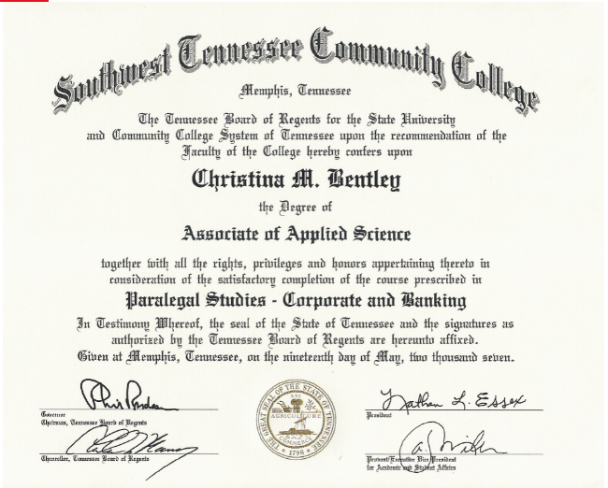

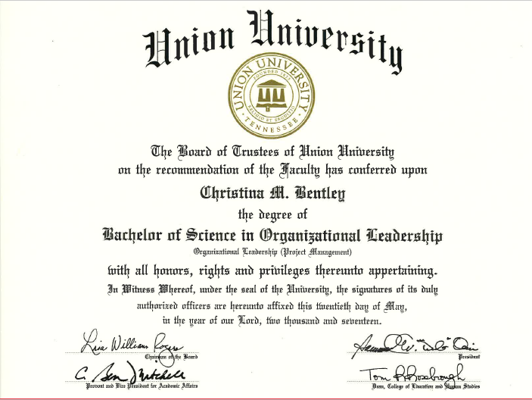

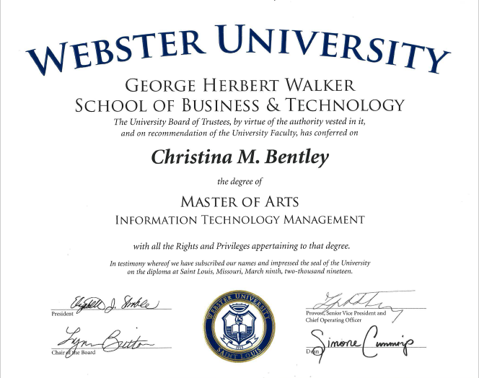

ch