http://www.youtube.com/watch?v=P8VLx39fiaA

https://www.youtube.com/watch?v=3D3AHkz2Zg8

https://www.youtube.com/watch?v=kl922PTZmXM&fbclid=IwAR1zljSLs-59dGgHrwn8fUbhDYpEEysrz4tVc49accOZrSaSw992UKo4O9M

https://www.youtube.com/watch?v=59LGAxKOolE&feature=youtu.be&fbclid=IwAR0cTFvNxhd8rpE_Uo4OhMuMsuLqwoVcddZZPjpvhrEud2yo9WHUmSoX3jU

https://www.youtube.com/watch?v=1Z1aVowS10A&t=11s

Thanks! Let me know if I can provide you with further details. Writing samples are available upon request.
I look forward to hearing from you soon.
Cordially,
David Martin

DAVID MARTIN
Writer/Producer
104 Manchester Court
Red Bank, NJ
07701
USA

dmartin10004@gmail.com
______________________________________________________
EXPERIENCE:

TELEVISION -- FILM -- THEATER -- RADIO

Writer of award winning short horror film NOT ALONE.

Producer/Director for DS Films. Supervised development and production of direct-to-video feature titles, documentary shorts and music videos.

Ghostwriter for feature cult classic BIRDEMIC.

Adapted acclaimed non-fiction World War II book On Burning Ground to a screenplay.

Office Assistant for The Jim Henson Company.

Writer/Performer on The Captain Cosmos Radio Show - WVBU Bucknell University.

Playwright for Firedrake Repertory Theater Company, New York City.

PA on I THINK I'M GONNA LIKE IT HERE directed by Chris Columbus.

Sound Boom on THE SILVER MAIDEN starring Eli Wallach.

Performed onstage with Sir Ian McKellen, Steve Buscemi and Mark Boone Junior.

NEW MEDIA

Contributor for Bohemian Renaissance, Octopus Media Group, NBC, Gabriel Studios, UK SOAP and The Gary Gannaway Group.

Freelance Writer for The New Republic, Shoot, The Money Review, Business Venture Magazine, The Hub, Generation X, Late Empire and The Asbury Park Press covering business, politics, entertainment and sports.

SKILLS:

Screenwriting, editorial, reporting, ghost writing, research, copywriting. All aspects of film and Digital Video production/post-production. Management skills. Amateur Archeologist. Mac & IBM. Final Cut Pro. MS Office.

EDUCATION:
Graduate of American Academy of Dramatic Arts.
New School University - Film and Video Arts.
Institute of Audio Research.
Political Science Major (Honors List) Brookdale Community College.

Original craigslist post:
https://washingtondc.craigslist.org/mld/wrg/d/greenbelt-writing-translations-articles/7682395890.html
About craigslist mail:
https://www.craigslist.org/about/help/email-relay
Please flag unwanted messages (spam, scam, other):
https://post.craigslist.org/mailflag?flagCode=34&smtpid=e2930f0c405288b59f454e999d8cbda792fc861c.1

Attachments area
Preview YouTube video Not Alone Trailer
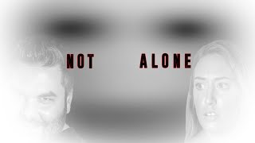
Not Alone Trailer
Preview YouTube video Busted Lust - trailer - promotion
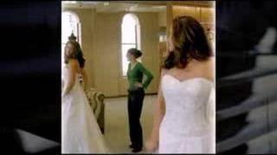
Busted Lust - trailer - promotion
Preview YouTube video Van Helsing Is Dead
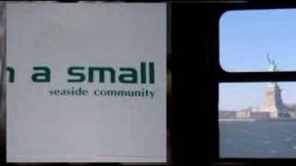
Van Helsing Is Dead
Preview YouTube video Arrivederci, Scafuzo!
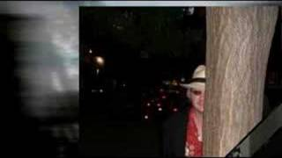
Arrivederci, Scafuzo!
Preview YouTube video Weirdo at the Laundromat

Weirdo at the Laundromat
Preview YouTube video #CONCEITED Starring Monye Tucker
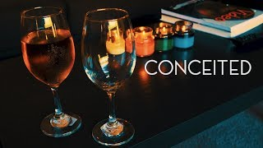
#CONCEITED Starring Monye Tucker
Preview YouTube video FADE OUT
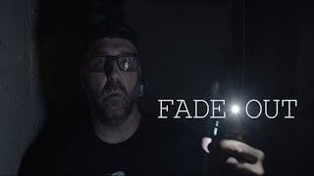
FADE OUT

ReplyReply allForward

