**ENRIQUE DE LOS SANTOS SANTIAGO JR.**

ARTICLE, CONTENT, CREATIVE, BLOG WRITER/ RESEARCHER/ ANALYST

**PRO FILE**

I'm a skilled writer with over ten years of writing experience touching on various topics and niches.

I focus on quality points to develop a material that will be a useful tool for my client. My services ensure my clients are looked after, and expectations are met.

My client's instructions are integrated into my research and analysis to create material that meets their needs. I am highly flexible and can utilize my research skills to cover different topics from reputable sources.

A missing period, a misspelled word, and improper grammar have no place in the content that I'm preparing. My writing style is simple, factual, and straightforward, ensuring that readers can easily grasp the message of the write-up.

My educational background, more than 20 years of corporate experience, and 12 years of business practice make it easier to convert thoughts and ideas into words. I’m a Bachelor of Science in Electronics and Communications Engineering (BSECE) and completed 39 units in a Master of Business Administration (MBA) program.

WORK EXPERIENCE

## **A. Freelance Writer**

## **Media: Track**

August 2020 to present

* The company provides media monitoring, measurement, and evaluation solutions to organizations in the media landscape. I prepare reports, summarize news content, and monitor news articles regarding the energy development in Nepal, TikTok, Canon products, food delivery platforms in Asia, United Overseas Bank (UOB) Limited, Petronas, and Qnet.

**William Y. (Upwork Client)**

November 2021 to October 2023

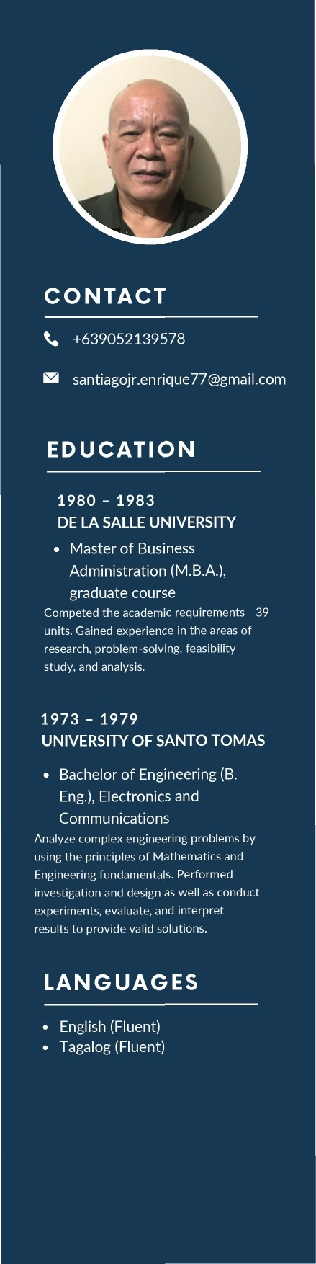

* I love basketball and I enjoy writing articles about the sport. Topics covered basketball history, life of NBA basketeers, and more. The experience enhanced my knowledge of basketball.

**Andava Digital Marketing Agency** April 2019 to February 2021

* I’m given topics to write with a format and keywords to use. The theme varies from cannabis, home design, food, and more. My skills in research, writing, and analysis were raised several notches.

# WORK EXPE RIE NCE

**Petrelli Previtera, LLC**

March 2020 to May 2021

* + Thomas Petrelli is a lawyer by profession, he gave me eBooks to write. This assignment gave me an opportunity to learn about legal matters.

## **Hyun Lee (Upwork Client)**

March 2020 to April 2020

* + My assignments from Hyun were about colleges in America. I learned that poverty is not a hindrance to education, there are colleges that offer scholarships to complete a degree debt-free.

## **OFW Update**

December 2018 to April 2019

* + Write-ups covered the plight of Overseas Filipino Workers (OFWs). Topics range from the treatment of employers to local and foreign regulations that affect their employment.

## **Prana**

## **Products**

July 2018 to December 2018

* + The client asked me to write articles about dogs which fascinated me. I'm a pet parent and love writing about man's best friend.

## **Amlee Media Advertisement**

January 2018 to February 2020

* + The client maintains a website about expatriates living in the Philippines. I suggest topics and prepare the material when it’s approved.

**Global Electives Port Limited**

August 2017 to February 2018

* + The company is a medical placement provider for student internships in the Philippines and Kenya. I handled all the write-ups on the website and prepared blogs to promote the business on other websites, terms and conditions, emails, and other tasks.

## **Vanan Group of Companies**

September 2015 to August 2017



* + The company offers a wide array of services. My writing assignments cover translation, transcription, typing, voice-over, closed captioning/subtitling, video spokesperson, and more.

**Philosophy Design Studios** February 2016 to September 2016

* + A blue and white card with text

    Description automatically generatedThey are engaged in the interior and exterior design of a home or office. My task is to write blogs on topics that they assign.

WORK EXPERIENCE

## **B. Corporate**

## **Technical Support Agent | Accenture** July 2007 – September 2008

Worked as a technical support call center agent, handling internet concerns by American clients.

## **Co-owner | Warehouse Unlimited** December 1999 – July 2001

The company handled the following activities:

* Sales of computer units, peripherals, software, and hardware.
* Installation and activation of network connections,
* Preventive and corrective maintenance of computers.

## **Section Supervisor |** January 1980 – December 1999

## **Philippine Long Distance Telephone Company**

## 

## Under my supervision were 39 field personnel to ensure all telephone lines within my work area. Top management assigned me to lead a team of supervisors to prepare a manual of work activities to be followed by field personnel. I was assigned as the head facilitator and trainer of the company’s Quality Control Circle program. The goal was to find solutions to work problems. I was sent overseas to train in fiber technology.

## **C. Profile Links**

## Upwork : https://www.upwork.com/freelancers/~0198f4a6aa00461b00

## Linkedin : <https://www.linkedin.com/in/enrique-santiago-jr-931a0b76/>

## Facebook: https://www.facebook.com/jun.santiago.5439/