SHARMAINE H. BUGARIN
 | 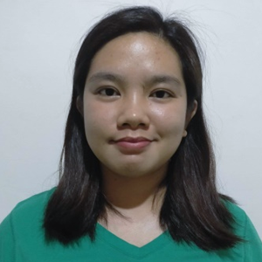 | #85 M.H. Del Pilar St. Balite, Montalban, Rizal  +63907-747-0000  sharmainebugarin349@gmail.com

Objective
To obtain a position that will enable me to use my strong organizational skills, educational background, and ability to work well with people.

Education

Elementary
Roosevelt College Rodriguez
2007-2008

High School
Roosevelt College Rodriguez
2009-2010

Skills & Abilities
- Trainable, can easily adjust to environment
- Can speak and understand English
- Self-Motivated, has initiative with a high level of energy and enthusiasm
- Able to learn quickly, dependable, hardworking
- Can work well both independently and as a team

personal data
Gender : Female
Civil Status : Single
Age : 26
Date of Birth : May 18, 1994
Place of Birth : Marikina City
Nationality : Filipino
Religion : Roman Catholic
Father’s Name : Reynato Bugarin
Mother’s Name : Virgie Bugarin

References

Reygielyn N. Bugarin, Task Us
0927-312-8309

Janilyn D. Estanislao, Principalia
0956-852-3044

I hereby certify that the above information is true and correct to the best of my knowledge and ability.

Sharmaine Bugarin
Applicant

