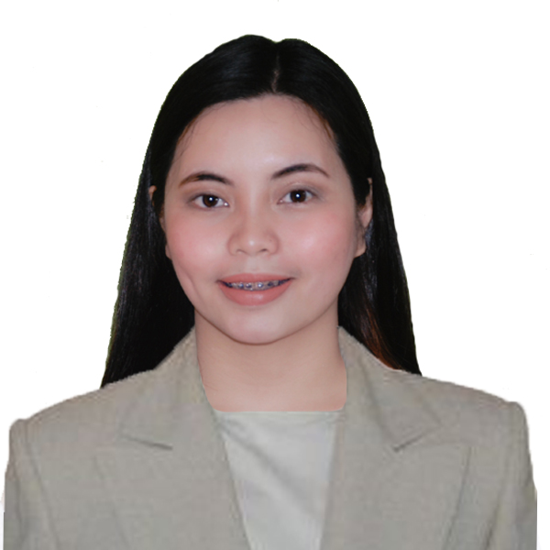

**JUDY ANN L. REYES**

Purok 1 Lambakin, San Miguel Bulacan

09650752842

lapuzreyesjudy@gmail.com

**OBJECTIVE:**

To obtain a challenging role in a reputable company and I will utilize my knowledge skills and abilities to help the company attain its goal; and become a valuable asset of the organization.

**EDUCATION**

**Tertiary**

EARIST 2016-2020

Nagtahan, Sampaloc Manila

Bachelor of Science in Hospitality

Management major in Cruiseline Operation

Baliwag University 2015

Bachelod of Science in Hospitality

Management

**Secondary**

Partida National hool 2011-2015

Partida, San Miguel, Bulacan

**Elementary**

Partida Elementary School 2005-2011

Partida, San Miguel, Bulacan

**SKILLS**

* Written and Verbal Communication
* Multi-tasking
* Leadership
* Time Management
* Ability to build good working relationship
* Willingness to learn and adopt new things

**WORK EXPERIENCE**

**SOLAIRE RESORT & CASINO ( INTERN)**

Finance Department and Concierge Department

Tambo Entertainment City, 1 Aseana Ave, Parañaque City

June 28, 2019- November 28, 2019

**IBUZZ TRAVEL & TOURS**

**January 24, 2020 - March 16, 202**

**AFFILIATIONS**

Supreme Student Government

P.I.O

2014-2015

Boy Girl OfficialMunicipal of San Miguel Bulacan

Sanguniang Bayan

2014

**SEMINARS ATTENDED**

Seminar Workshop on Personality Development

Nagtahan , Samapaloc Manila

September 24, 2016

Seminar Workshop on Food Safety Hygiene and Sanitation focus on HACCP System

Nagtahan, Sampaloc Manila

September 24, 2016

Philippime Young Entrepreneurs Seminar- Briefing on "Efective Supervisory to Enhance

Productivity and Quality "

U.N Avenue Manila

September 29, 2018

NC ll Passer ( Front Office Services)

March 27, )2018

**REFERENCES**

**Renato G. de Rueda**

Municipal Assesor

San Miguel Bulaca

Contanct No# +639676594657

**Celerina R. Dimaandal**

Businesswoman

Contact No. 09751233404