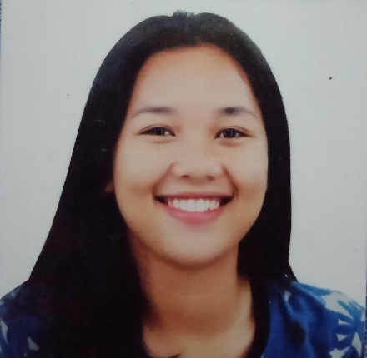**DWAYNE SHAY T. VILLANUEVA**

San Miguel Compound, Purok8, Pitogo Consolacion

Cebu 6001

0921-672-0714

[Dwayneshay27@gmail.com](mailto:Dwayneshay27@gmail.com)

**POSITION**

**APPLIED: CHAT SUPPORT REPRESENTATIVE**

**PERSONAL**

**INFORMATION:**

Age: 20 years old

Birth Date: July 19, 2000

Sex: Female

Civil Status: Single

Citizenship: Filipino

Religion: Catholic

Height: 5’5”

Weight: 70 kgs.

Father’s Name: Jerome P. Villanueva

Mother’s Name: Baby T. Villanueva

Parents Contact No: 0906-670-2060

**OBJECTIVES:** To be able to enhance my abilities and ready to explore and learn new things.

**EDUCATIONAL**

**ATTAINMENT:**

**Cebu Technological University**

**Bachelor of Arts in English Language**

1st and 2nd year college (2018-2020)

**Jugan National High School**

**General Academic Strand (GAS)**

Senior High, 2016-2017

**Jugan National High School**

**JuganConsolacion Cebu**

Secondary Education,2012-2016

**Cansaga Elementary School**

**CansagaConsolacion Cebu**

Primary Education,2008-2012

**Danglag Elemetary School**

**Danglag Consolacio Cebu**

Primary Education, 2006-2008

**SKILLS:**

* Good in communication skills
* Good in adjusting different personalities
* Knows how to handle the customers

**AWARDS AND**

**RECOGNITION**:

**Finalist, Doce Pares (Arnis)**

July 2013

**Theater Cast, MHCC (WalaySukod)**

February 22, 2015

**3rd runner-up, Miss Danglag**

May 1, 2015

**Certificate of Leadership, CAT (Major S4)**

April 4, 2016

**Awardee, Academic Excellence (JNHS)**

February 04, 2017

**Certificate of Appreciation, SSG (JNHS)**

August 6, 2017

**Awardee, Academic Excellence (JNHS)**

September 10, 2017

**Awardee, Academic Excellence (JNHS)**

November 12, 2017

**Awardee, Academic Excellence (JNHS)**

April 6, 2018

**Dean’s Lister (CTU-MC)**

March 16, 2018

**WORKING**

**EXPERIENCE**:

**Partime job, Realty (flyers)**

BahakLilo-an Cebu

2013

**Reliever, Native Food Exhibitor (SM Cebu**)

North Reclamation Area, Mabolo

Cebu City, 6014 Philippines

2017

**Encoder, Job Order (CMPC)**

Cansaga, Consolacion, Cebu

January 2020

**CHARACTER**

**REFERENCES:**

**JEANIE RAFOLS**

Address: Poblacion Consolacion Cebu

Teacher, Jugan National High School

*Mobile No:* 0939-895-7564

**JESON A. BUSTAMANTE, Ed.D**

Faculty, College of Arts and Sciences, Cebu Normal University

0917 128 0425

bustamantej@cnu.edu.ph

**TEMPORA BALABA**

Address: Pulog Consolacion Cebu

Teacher, Jugan National High School

*Mobile No: 09173922304*

***I hereby certify that all information are true & correct to the best of my knowledge and belief.***

**DWAYNE SHAY VILLANUEVA**

**Applicant**