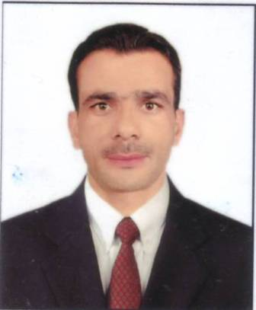

|  |  |
| --- | --- |
| we*URICULUM*  *ITAE* | **Address:**  House No: 3 , Block-B, Al-Garden, Rana Town,  Shahdara Lahore, Pakistan.  Postel Code: 54900  **Mobile:** +92300-8078358 - +92300-4869123  **Email ID: zahidwaqar77@gmail.com** |

**OBJECTIVE**

To achieve challenging position in a dynamic and well reputed organization/institution this offers good opportunities and challenging working environment, where I could implements my knowledge.

**PERSONAL PROFILE**

* Father’s Name: Riaz Ahmed
* Date of Birth: 11-05-1992
* N.I.C Number: 34602-0496708-1
* Passport No: ZR0157082
* Gender: Male
* Marital Status: Single
* Nationality: Pakistani

**ACADEMIC QUALIFICATION**

**Matriculation 2011 2nd Division**

Board Of Intermediate & Secondary Education,

Lahore.

Professional Chef

2018 B Grade

National Vocational & Technical Training Commission

Government Of Pakistan.

**PROFICIENCY IN LANGUAGE**

* Urdu
* Punjabi
* English

**EXPERIENCE**

* 3 year work experience in “Pappu Catering & Swad Restaurant” as a “Professional Chef”.

**HOBBIES**

* Cricket
* Wali Ball
* Foot Bal