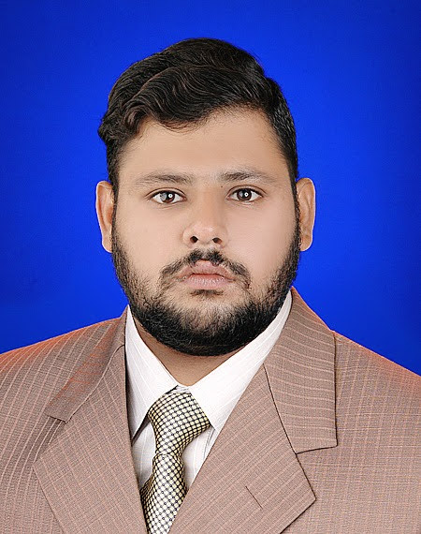

PARDEEP KUMAR

PERMANENT ADDRESS:
S/O Nanik Ram Sobhani,
House# 811/812 B Gajwani Mohalla,
Rohri, Distt. Sukkur, Pakistan
Mobile: +923113595439
Email: Sobhanipardeepkumar@gmail.com

PRESENT ADDRESS:
House# Flate No D60 Block D-5 Floor 4 Rabia city
Near Johar chorangi,Gulstan-e-johar karachi
Sobhanipardeepkumar@gmail.Com
Mobile: +923113595439
Email: Sobhanipardeepkumar@gmail.com

PROFILE / SKILLS:
- Can work as: IT Bank Officer, IT Project Officer, IT Office Assistant, Data Entry Operator, Admin Assistant and Office Clerk.
- Dedicated and hardworking.
- Professionally trained during internship

- QUALIFICATION;
- BLIS Bachelor of Library & Information Science:Passed in 2018 Allama Iqbal Open University Islamabad

- Bachelor of Science (IT): Passed B.S. Computers in 2019 obtained 2.68% CGPA/ Grade C
- From Shah Abdul Latif University Khairpur
- Thesis Project: Designed Program for Stock Market Analysis and Predictions – Presented on Feb 13, 2020.

- Intermediate: Pre-Engineering, Passed in A1 grade in 2015
- From Govt. Higher Secondary School Salehput

- Matriculation: General Science , Passed in A grade in 2013
- From Govt. Higher Secondary School SALAHPAT

- EXPERIENCE:
- Internship: Worked as Data Entry Assistant in Shah Abdul Latif University, Khairpur
- On Voluntarily basis for Library Data Updating – July 2017.
- SKILLS: MS Office, Team working, Fast Learner
- PERSONAL INFORMATION:
- Father Name: Nanik Ram Sobhani
- Date of Birth: December 27, 1996
- Passport#: EN42205021 (Issued: Jun 5, 2018 & Expiry: Jun 4, 2023)
- CNIC#: 45502-5630502-5
- Nationality: Pakistani
- Languages: English, Urdu, Hindi, Sindhi,
- Religion: Hinduism
- REFERENCE: Reference shall be provided on demand.

