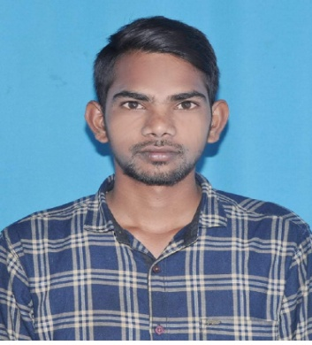**MAHAMMAD MAJAHAR BASHA**

**Mobile No: - 6300705782**

**Email id: -** [**majaharbasha136@gmail.com**](mailto:majaharbasha136@gmail.com)

**Date of Birth: 03/06/1997**

**Father’s: Mahammad Mazeed**

**Address: H.No 5/ T.Somalagudur village Nandhavaram Mandal Kurnool District1**

**Post Graduate - fresher Specialization: FINANCE**

**OBJECTIVE:**

To learn and grow and to keep up myself and organization I am working for.

ACADEMIC QUALIFICATIONS:

|  |  |  |  |  |
| --- | --- | --- | --- | --- |
| **Year** | **Qualification** | **Board/University** | **Institute** | **Percentage** |
| 2018-2020 | MBA | JUNTUA  University | ST.Johins Collage Engineering Technology  Yerrakotta ,yemiganur | 7.0% |
| 2015-2018 | DEGREE  (B.B.A) | Rayalaseema University | Vyshnavi Degree College, Yemmiganur, , Kurnool Dist,Andhra Pradesh. | 6.9% |
| 2013-2015 | Inter Mediate  (C.E.C) | Board Of Intermediate Education | Vyshnavi Junior College,  Yemmiganur,  Kurnool Dist,AP. | 5.0% |
| 2012-2013 | (SSC) | BOARD OF SECONDARY EDUCATION | Zp High School, Daivamdinne, Kurnool Dist,Andhra Pradesh | 5.0% |

**LIVE PROJECT:**

**PROJECT: 1 NON PERFORMING ASSETS, (At Shriram City Union Finance ltd.Yemiganur)**

**PROJECT: 2 SOWT ANALYSIS AT HDFC BANK IN YEMIGANUR**

**TECHNICAL QUALIFICATIONS:**

* **COMPUTER SKILLS :**  PGDCA Tally ERP 9 GST
* **TYPING :** English
* **CERTIFICATION :**     ntel

**PERSONAL INFORMATION:**

**Name :** Mohammad Majahar Basha

**Father’s Name** **:** M.Mazeed

**Mother’s Name** **:** M.Chand bee

**Gender** **:** Male

**Date of Birth** **:** 03/06/1997

**Language Known :** English, Telugu and Urdu, Hindi.

**Nationality** **:** Indian

**Strength** **:** Confident, Positive Attitude, Quick learner,

**DECLARATION:**

I hereby inform you that all the statement made above are true to the best of my knowledge and belief.

**Date:**

**Place:**

**M.MAJAHAR BASHA**