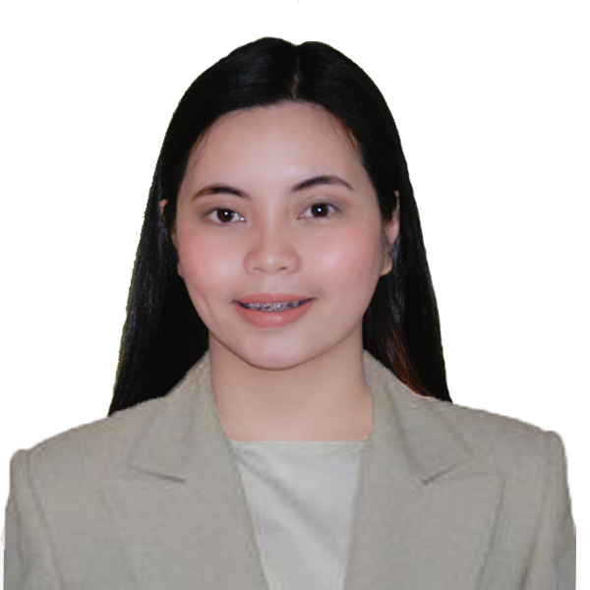
JUDY ANN L. REYES
Purok 1 Lambakin, San Miguel Bulacan
09650752842
lapuzreyesjudy@gmail.com

OBJECTIVE:

To obtain a challenging role in a reputable company and I will utilize my knowledge skills and abilities to help the company attain its goal; and become a valuable asset of the organization.

EDUCATION
Tertiary
EARIST 2016-2020
Nagtahan, Sampaloc Manila
Bachelor of Science in Hospitality
Management major in Cruiseline Operation

Baliwag University 2015
Bachelod of Science in Hospitality
Management
Secondary
Partida National hool 2011-2015
Partida, San Miguel, Bulacan

Elementary
Partida Elementary School 2005-2011
Partida, San Miguel, Bulacan

SKILLS
- Written and Verbal Communication
- Multi-tasking
- Leadership
- Time Management
- Ability to build good working relationship
- Willingness to learn and adopt new things

WORK EXPERIENCE

SOLAIRE RESORT & CASINO ( INTERN)
Finance Department and Concierge Department
Tambo Entertainment City, 1 Aseana Ave, Parañaque City
June 28, 2019- November 28, 2019

IBUZZ TRAVEL & TOURS
January 24, 2020 - March 16, 202

AFFILIATIONS

Supreme Student Government
P.I.O
2014-2015

Boy Girl OfficialMunicipal of San Miguel Bulacan
Sanguniang Bayan
2014

SEMINARS ATTENDED

Seminar Workshop on Personality Development
Nagtahan , Samapaloc Manila
September 24, 2016

Seminar Workshop on Food Safety Hygiene and Sanitation focus on HACCP System
Nagtahan, Sampaloc Manila
September 24, 2016

Philippime Young Entrepreneurs Seminar- Briefing on "Efective Supervisory to Enhance
Productivity and Quality "
U.N Avenue Manila
September 29, 2018

NC ll Passer ( Front Office Services)
March 27, )2018

REFERENCES

Renato G. de Rueda
Municipal Assesor
San Miguel Bulaca
Contanct No# +639676594657

Celerina R. Dimaandal
Businesswoman
Contact No. 09751233404

