Main idea of the game journey of Temuyin:

- User download the App and starts by choosing his next real travel mission and eventually challenge another player for next month
- User accumulate each month his monthly individual performance provided by online Salesforce connection or daily manual upload.
- User can win coins every month that he will need in order to pay for his next travel mission. He will earn coins only if he is inside the Top Performers of the month. By default, it is going to be the 20% of all players but the manager can change that number on the settings
- If the user achieves the amount of performance points to get into the next game category, automatically the system opens the padlock of the next level. Now he is authorized to unlock this level but only if he has enough coins to pay for the travel mission. If not, the user got stuck in the level until he makes the necessary coins to unlock the next level.
- In case the user has enough coins to pay for the next mission but not enough performance points, he necessarily has to achieve the amount of points in order to open the padlock; so he cannot use the coins with a closed padlock
- In basic terms, performance points are for open the padlock and the coins are for unlocking the next level by paying for the next mission.
- As the user starts to go to higher game levels, he will be able to use the coins for more attractive travel mission. In the first level, he only can choose between local trips (inside his country) but since the user starts to move from level to level, he starts to choose trips outside his country and continent. As described at the beginning.

How to set up the coins at the beginning by the game manager:

- First, the game manager has to fill a spreadsheet (or other format) with all of the users of the game, specifying the following information for each user:

  - Complete name (formal name not nickname)
  - Corporative email (username)
  - Team number (for hierarchy reasons)
  - City (for hierarchy and profile reasons)
  - Country (for hierarchy and profile reasons)
  - Type (what of the 4 types of user like, player, team leader, team manager or country manager)
  - Zone (for hierarchy reasons in terms of what does the type cover)
  - Department (what department does the user work) (I will explain later why is this) (like sales, marketing, call center, etc)

- Once this is done, the system (excel or other) shows immediately the total number of users for each department.
- Now it’s time the manager decides the total annual budget he is willing to consider in order to finance the real travel trips. Let’s say the manager says US$60.000
- Now the game manager has to decide what percentage of this annual budget should go to each department (example: 70% for sales, 8% for marketing and 22% for call center)
- The system automatically shows the expected monthly money fund for each department, each month. This monthly fund will be the money that each month will be distributed between the top performers of each month for each department.
- Now the manager has to decide what percentage of the total users for each department should be considered for monthly payment. He might consider that the top 20% of sales department should win monthly fund and only the top 10% of the marketing department.
- Depending on the total users per department, the annual budget and the percentage considered to award the top performers each month, the system automatically gives you an approach of how much money (coins) could a top performer earn each month.
- This information is important because it gives the manager an idea if he has to move any settings in order to make the game viable. Different situations can occur, like: If monthly expected payment is too low, it can demotivate the player and destroy the game so the game manager has to:

  - Increase the annual budget until it reaches a minimum suggested of $20 for each user
  - Decrease the number of users by eventually eliminating one or more departments
  - Decrease the percentage of users he wants to reward every month for each department
  - Change the distribution of the annual budged between departments

- At the end, the game manager has to open an account with Expedia, connect his Temuyin account with Expedia and authorize payment of his credit card at least a 10% of the annual budget of the game.

Note:
Setting the game is very important in terms of the different goals each company could have in terms of motivating their teams. Every company is different and that force us to create enough settings that can fit into their personal goals without affecting the main idea of the game.

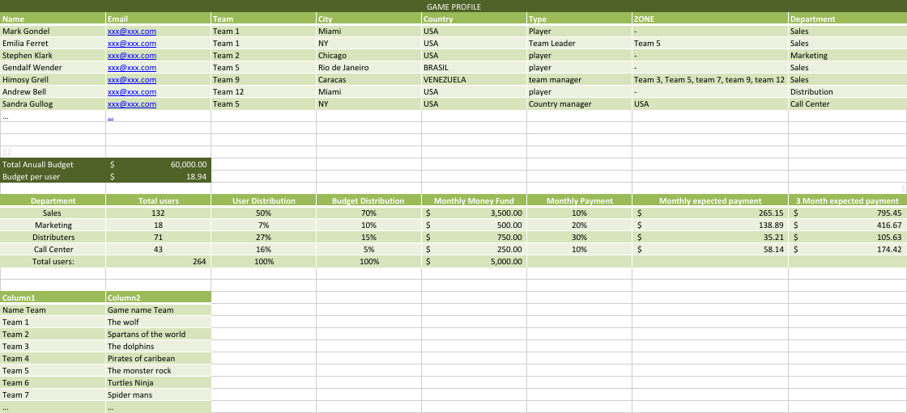

Types of players

I still need to figure out how to pay coins to other users different then players like team leaders, team managers and country managers. I am thinking about it. Do you have any suggestion?

